College of Science, Technology and Applied Arts



of Trinidad and Tobago

## DIVISION OF LIBERAL ARTS AND HUMAN SERVICES

## 

**Assignment: Capstone Project**

# STAT 401: Multivariate Statistical Analysis



2022-2023, Semester 2

05.06.23

22593

00042780

Kenroy Anthony Adams

**Acknowledgements**

I would like to thank my wife Marisha Morris-Adams and my son, Takeo Solomon Adams for their unwavering support in this project and by extension, my undergraduate studies in Mathematics. I also wish to thank all people who would have inspired me to pursue Mathematics at a tertiary level. Such people include my Secondary School Mathematics teacher, Ms. Smith, who first introduced me to infinity and consequently sparked my love for Mathematics. I would also like to express my sincere gratitude to Dr Hernandez for his invaluable guidance and for demonstrating the immense power of the field of Statistics during my enrollment in STAT 200.

**Introduction**

The data set being used was taken from the UCI Machine Learning Repository and it focuses on forest fires. This data set stood out to me as a fire fighter having to deal with bush fires annually during the dry season. It is my hope that some degree of knowledge and information obtained from analyzing this data set can somehow be beneficial to my line of work. Even though locally we deal with bush fires as opposed to forest fires, there have been many incidents of these bush fires damaging property. These incidents are very similar to what happens with forest fires even though the actual size of the areas affected is much smaller.

The variables provided are as follows: Month, spread index, Temperature, Relative humidity, Wind speed, Rain and Area burned.

The objective of this exercise is to ascertain whether the given variables are determining factors in the area burned by forest fires. Further to this, the following questions will be answered:

1. Are variable pairs independent of each other?

2. How many pairs of numerical data are present in the given data set?

3. What does PCA results tell us about the data set?

4. What do the plots tell us about the data set?

**Method**

The main software being utilized for this project is RStudio. According to the Kent State University, RStudio is a free, open-source IDE for the R programming language. The R programming language is an open-source program used for statistical analysis, based on the S language. The interface of RStudio is organized in such a way that users can clearly view graphs, data tables, R code and output all at the same time.

The actual method would begin by first importing the data set named ‘forestfires’ into RStudio for analysis. However, upon importing the data, we must do perform a cursory glimpse of the data which includes but is not limited to; determining the number of rows and columns, examining the overall structure of the data set, determining the number of NA cells, determining the total number of rows with NA cells, determining the percentage of NA cells in the dataset to get a real sense of how much of the data set is actually missing. Having done this, the data would need to be cleaned accordingly.

Further to this univariate, bivariate and multivariate analyses of the data will be conducted, which will enable us to obtain meaningful information from the data set, thereby enabling us to make meaningful inferences and conclusions.

**Cleaning the data set**

Having imported the data set, the following it is observed in the Global Environment window that there are 517 rows of 7 variables. This is verified by pasting the source code into the console and using the View(forestfires) line of code.

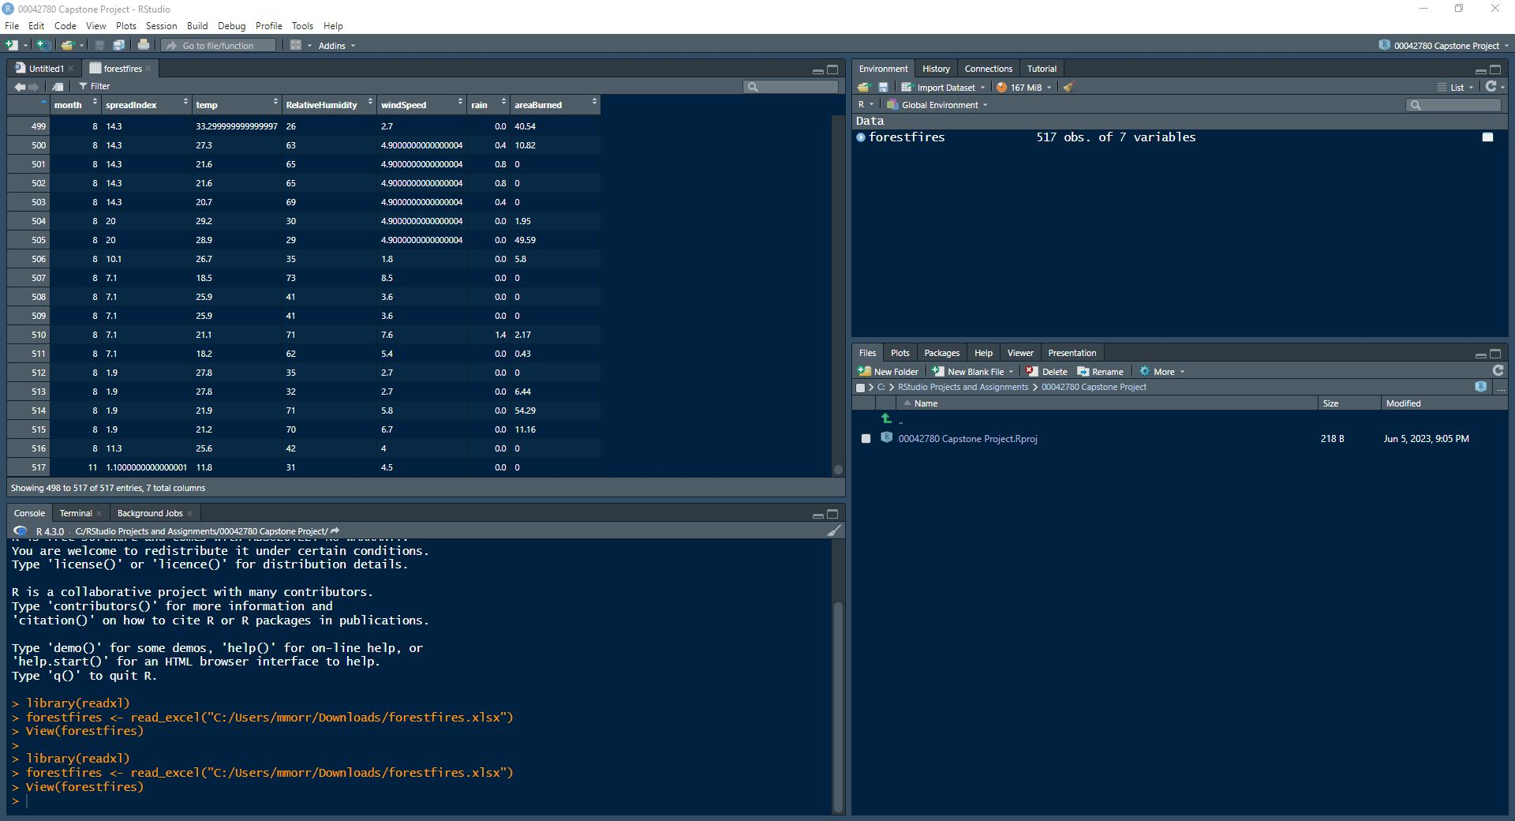

By hovering over the columns, the datatypes are seen as follows:

Month – numeric, SpreadIndex – character, temp – character, RelativeHumidity – character, windspeed – character, rain – numeric, areaBurned – character.

Considering these observations, month should be categorical, SpreadIndex, temp, RelativeHumidity, windspeed and areaBurned should all be numeric data types. This can be addressed by using the following lines of code:

as.numeric(forestfires$spreadIndex)->forestfires$spreadIndex

as.numeric(forestfires$temp)->forestfires$temp

as.numeric(forestfires$RelativeHumidity)->forestfires$RelativeHumidity

as.numeric(forestfires$windSpeed)->forestfires$windSpeed

as.numeric(forestfires$areaBurned)->forestfires$areaBurned

as.character(forestfires$month)->forestfires$month

Having executed these lines of code, followed by a refresh of the dataset using the view function as follows:

View(forestfires)

We were able to address the data types of the respective variables. We now have Month – character, SpreadIndex – numeric, temp – numeric, RelativeHumidity – numeric, windspeed – numeric, rain – numeric and areaBurned – numeric

Output as follows:

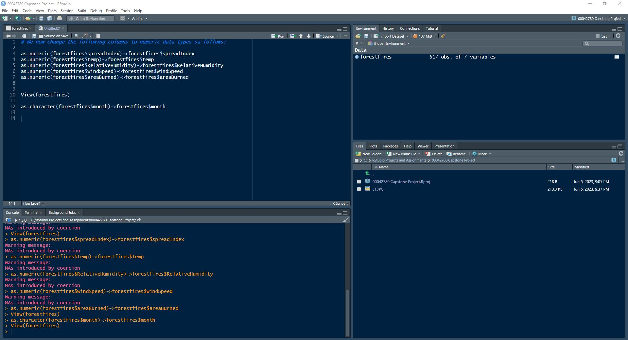

We now need to clean our dataset. The process of cleaning our dataset involves dealing with **missing** data and dealing with **duplicate rows** of data. Let us first look for duplicated rows using the following line of code:

NoDupforestfires <-unique(forestfires)

Using this line of code, we do two things at the same time. We are both removing duplicated rows of data and creating a new data frame without the duplicated data called NoDupforestfires.

The screenshot below shows the use of the unique function as well as the creation of the new data frame, without the duplicated data.

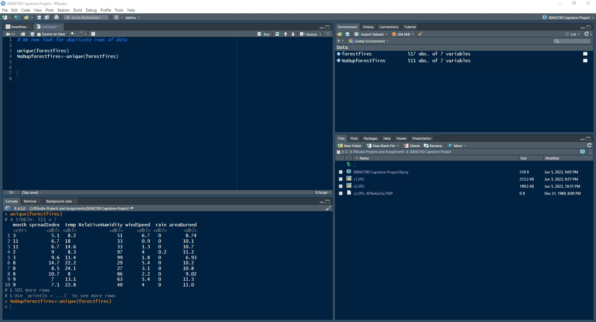

We now view the newly created data frame using the View function as follows:

View(NoDupforestfires)

Output as follows:

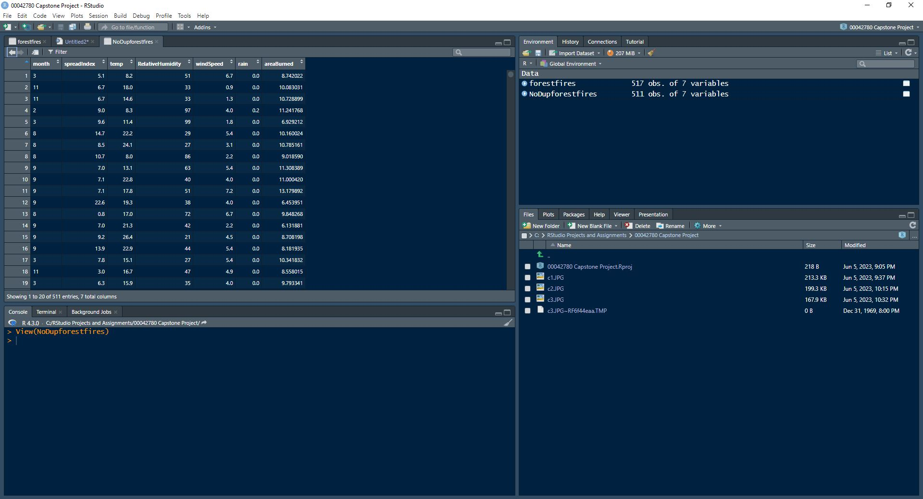

We now have a data frame consisting of 511 rows and 7 columns. We must now deal with missing data. This is done by using the following lines of code:

length(which(is.na(NoDupforestfires)))

length(which(!complete.cases(NoDupforestfires)))

This is to be accompanied by a ‘**missingness**’ plot to provide a visual representation of the missing data.

The output below shows us that there are 18 NA’s and 18 rows containing NAs.

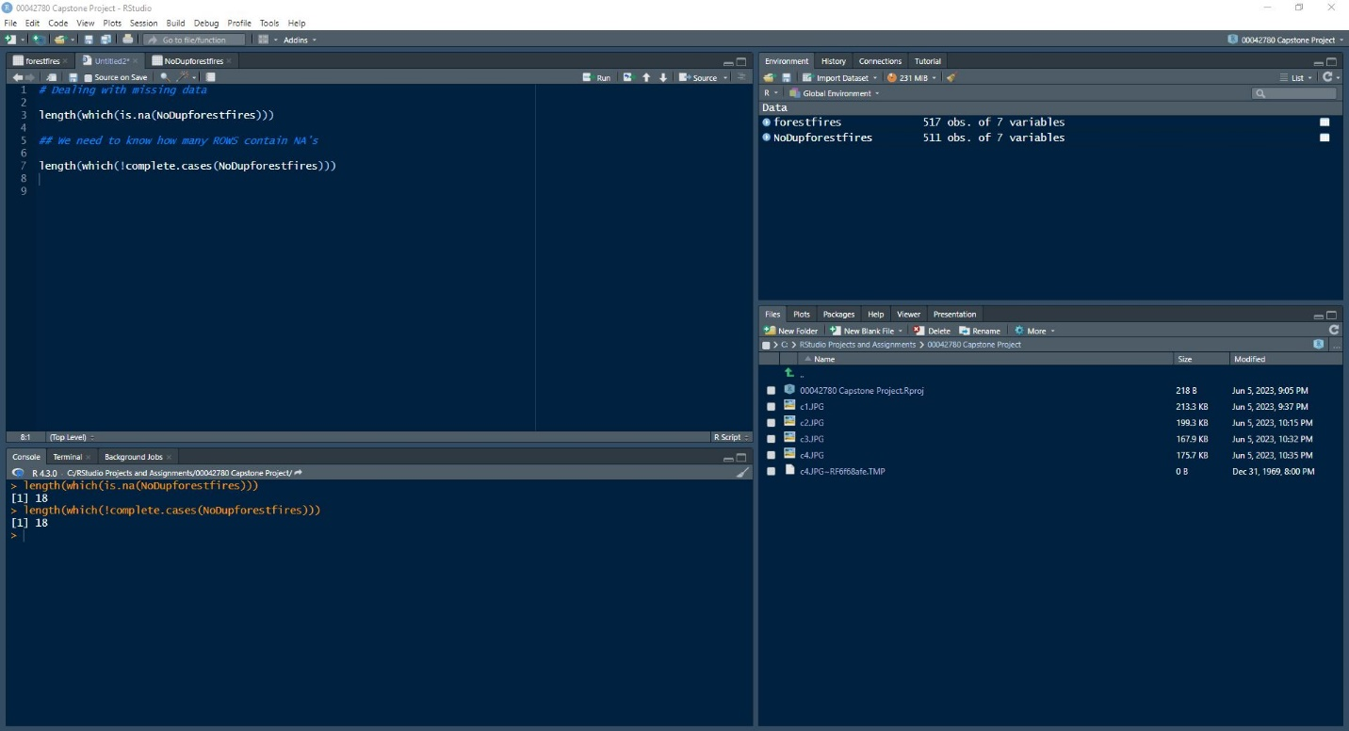

Let us now obtain a visual representation of the missing data. To achieve this, we need to install the **Amelia** package, then use the missmap function. Output as follows:

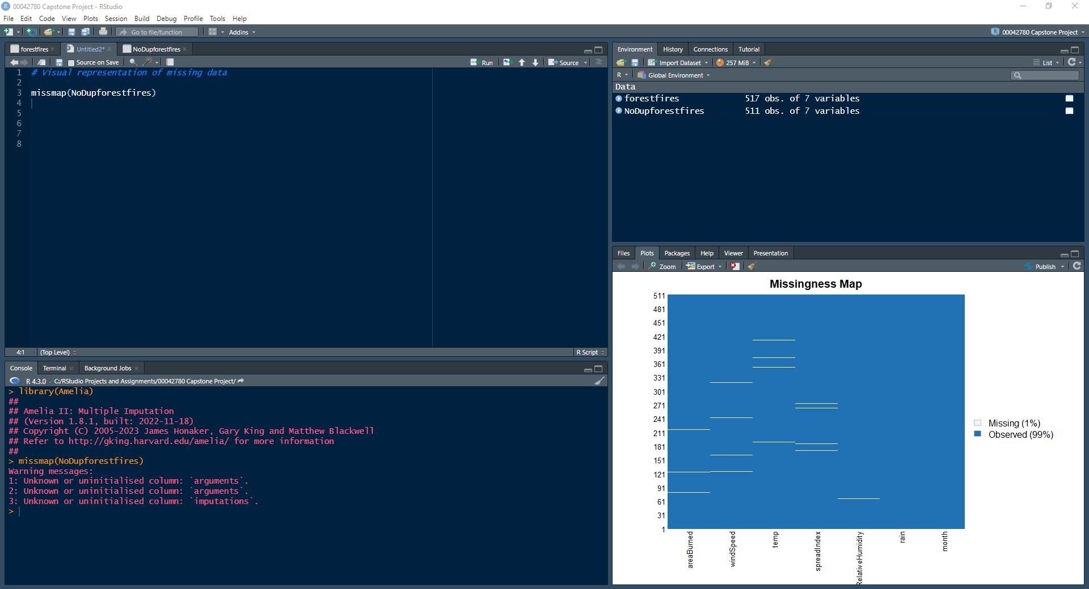

As a rule, there should be no more than 5% of the data missing. In this case, only 1% is missing. In this case our data set is usable and can indeed be analyzed.

The cleaning process must now be completed by using mean imputation to deal with the missing data. It must be noted however, that the process of mean imputation changes the data set from a data frame into a matrix. This implies that before we proceed with our analysis, we must change the matrix back into a data frame.

For **Mean Imputation**, we start by sub-setting the data set to ensure that all the data types are numeric:

Done as follows:

SubFF<-NoDupforestfires[ ,2:7]

This line of code removes the month column which is categorical(character type)

We now apply Mean imputation to our newly created SubFF data frame as follows:

NewForestFires<-apply(SubFF,2,function(x){x<-replace(x,is.na(x),mean(x,na.rm=TRUE))})

We now have a matrix called NewForestFires which must be first re-converted into a data frame, then we need to replace the month column.

Refer to the screenshot below:

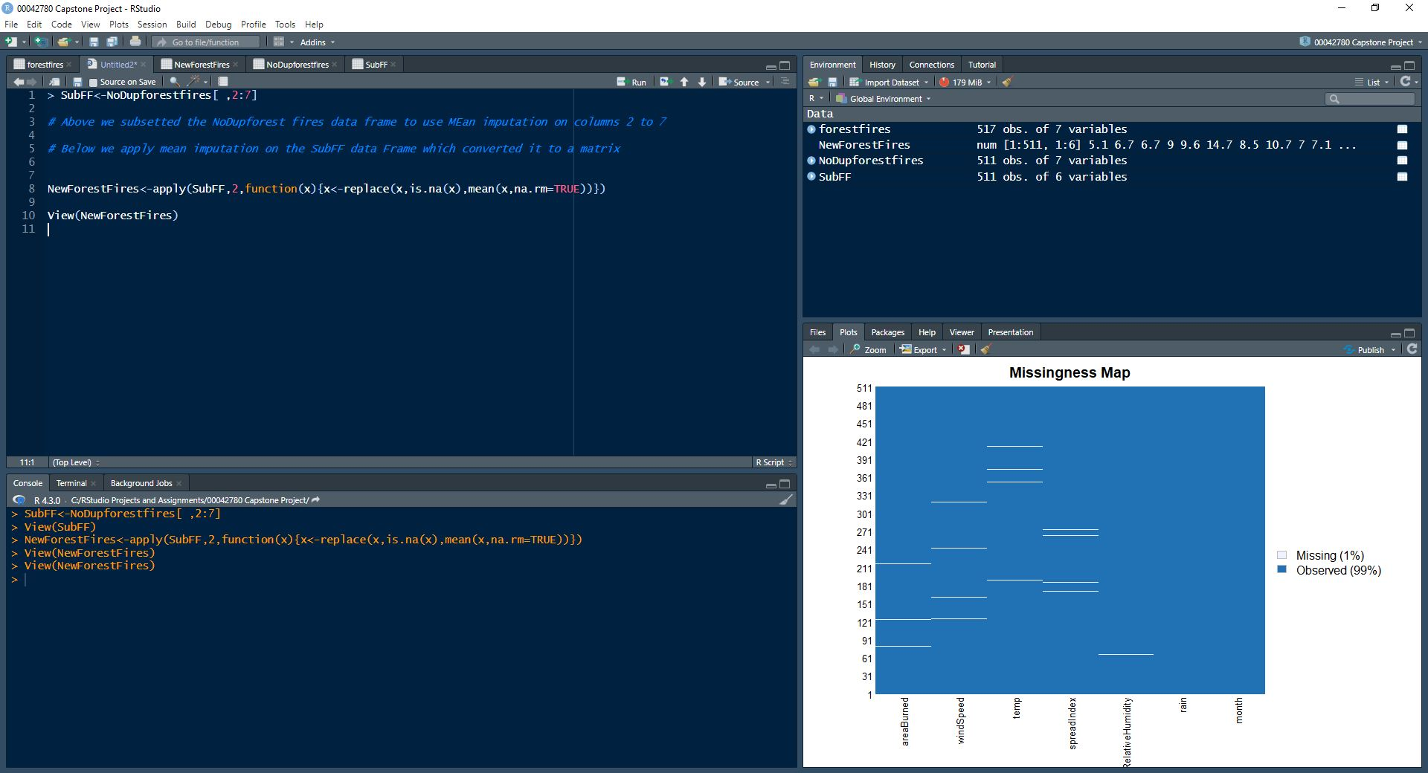

Let us now re convert NewForestFires into a Data frame.

ForestFiresDF<-as.data.frame(NewForestFires)

We now need to add the month column using cbind as follows:

A<-cbind(NoDupforestfires$month,ForestFiresDF)

Using the View function, we have the following:

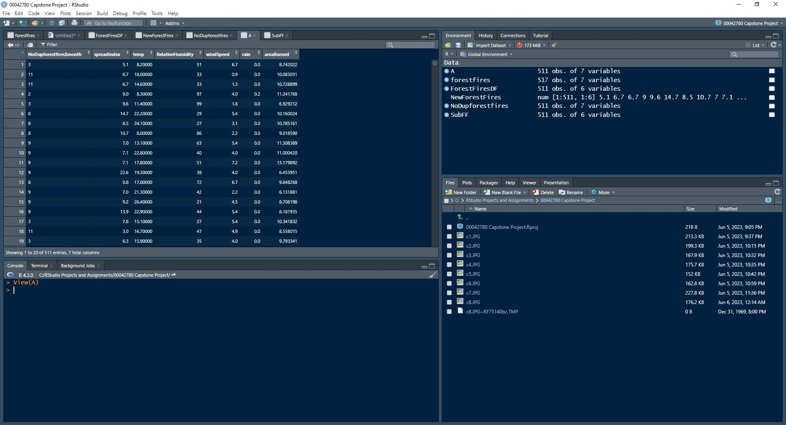

So now, we have a data frame called A which has no repetition of rows, and all of the NAs would have been dealt with using Mean Imputation. We have a clean data set and can now begin our respective analytical processes. Let us obtain a summary of our data frame, A. This is done using the summary function as follows:

summary(A)

Output as follows:

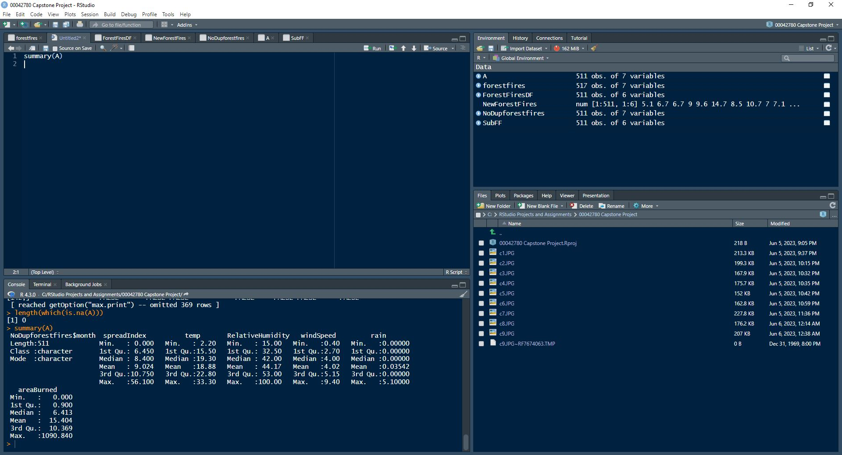

We can now have a look at different properties of the data set, namely, the number of columns, the number of rows, the head, the tail and the overall structure. These properties are obtained by selecting the **MVA** package and using the following lines of code:

ncol(A)

nrow(A)

head(A)

tail(A)

Output as follows:

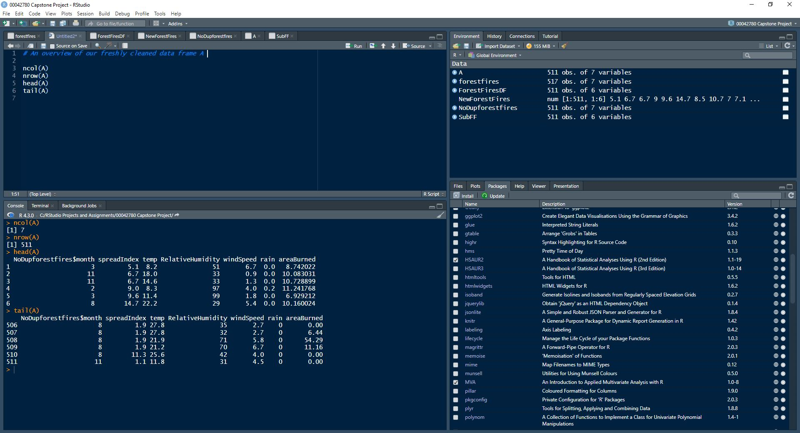

The summary screenshot above shows us the summary statistics for the numeric columns namely, the minimum, the 1st quartile, Median, Mean, 3rd Quartile and Maximum. Now that we have a clean data set, we can begin our analytical processes.



**Analysis**

**Testing for Univariate Normality and Bivariate Independence**

We begin by testing the data set for univariate normality and Bivariate Independence. Conducting these tests is made up of the following points of focus:

1. The Quartile-Quantile Plot

2. The Shapiro Test for Independence

3. The Chi plot Test for Independence

4. The Chi Square/Hypothesis Tests for Independence

To conduct these tests, we only need the columns made up of numeric data types. For this reason, we will be using the previously created ForestFiresDF data frame which contains no duplicates, no NAs and only the numeric columns.

**The Quartile-Quantile Plot**

We will be testing each variable for normality as follows:

qqnorm(ForestFiresDF$spreadIndex, col =”blue”,pch=15)

A line is then superimposed on to the plot as follows:

qqline(ForestFiresDF$s,colpreadIndex, lty=1, lwd=2, col=”blue”)

The plot obtained is as follows:

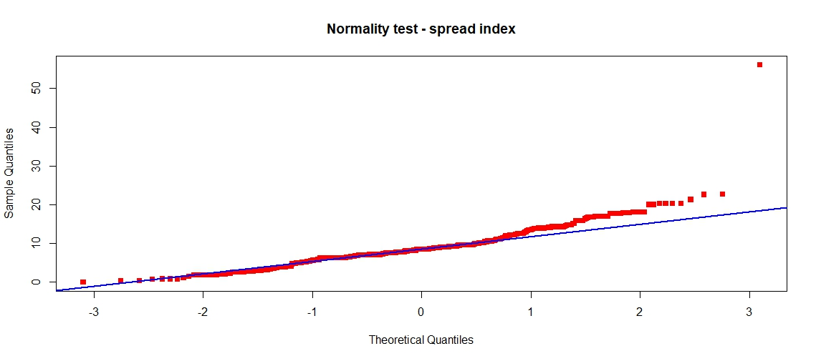

The process is repeated for each numeric variable as follows:

**Normality test for the temperature variable:**

qqnorm(ForestFiresDF$temp,col="red",pch=15)

qqline(ForestFiresDF$temp,lty=1, lwd=2,col="blue")

**Normality test for the Relative Humidity variable:**

qqnorm(ForestFiresDF$RelativeHumidity,col="red",pch=15)

qqline(ForestFiresDF$ RelativeHumidity,lty=1, lwd=2,col="blue")

**Normality test for the wind speed variable:**

qqnorm(ForestFiresDF$windSpeed,col="red",pch=15)

qqline(ForestFiresDF$ windSpeed,lty=1, lwd=2,col="blue")

**Normality test for the Rainfall/Precipitation variable:**

qqnorm(ForestFiresDF$rain,col="red",pch=15)

qqline(ForestFiresDF$rain,lty=1, lwd=2,col="blue")

**Normality test for the area burned variable:**

qqnorm(ForestFiresDF$areaBurned,col="red",pch=15)

qqline(ForestFiresDF$areaBurned,lty=1, lwd=2,col="blue")

The outputs are as follows:

Temperature:

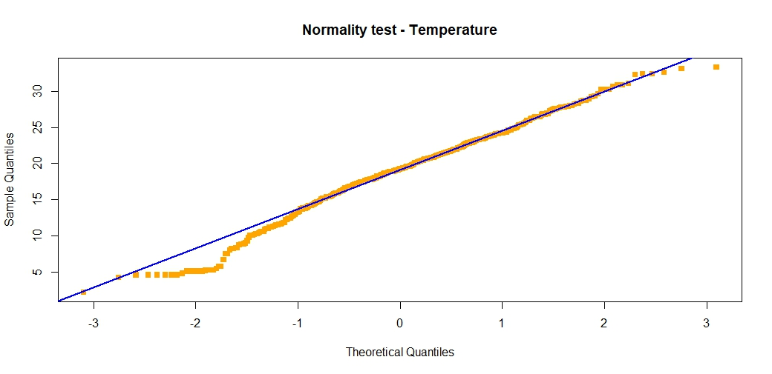

Relative Humidity: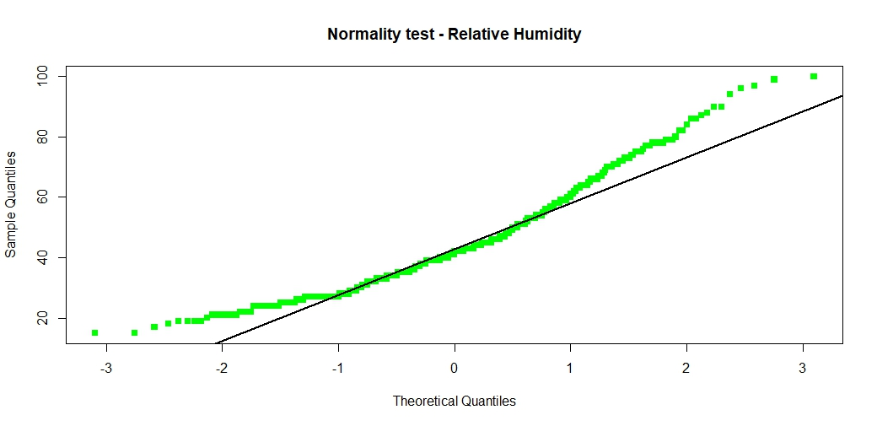

Wind Speed:

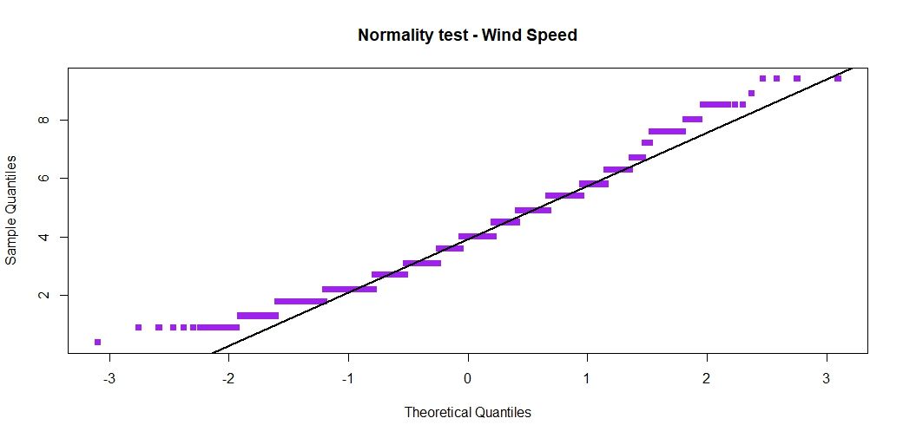

Rainfall:

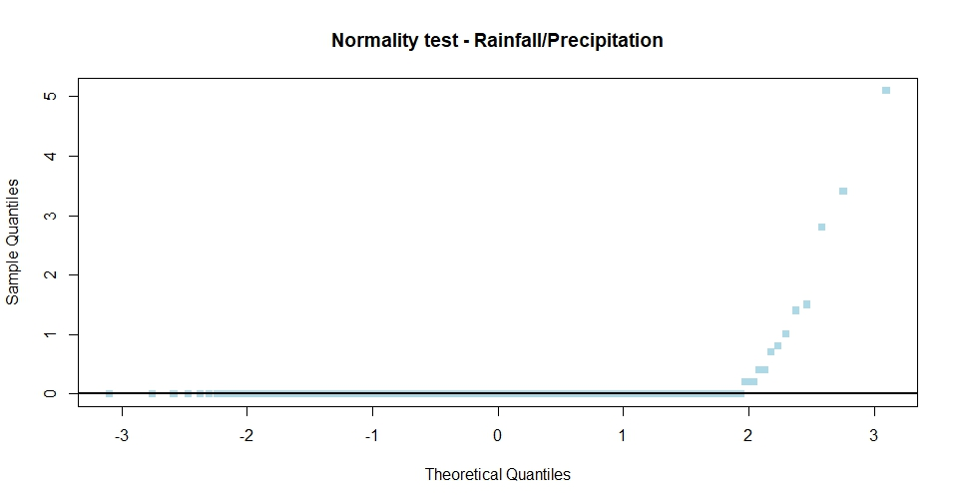

Area burned:

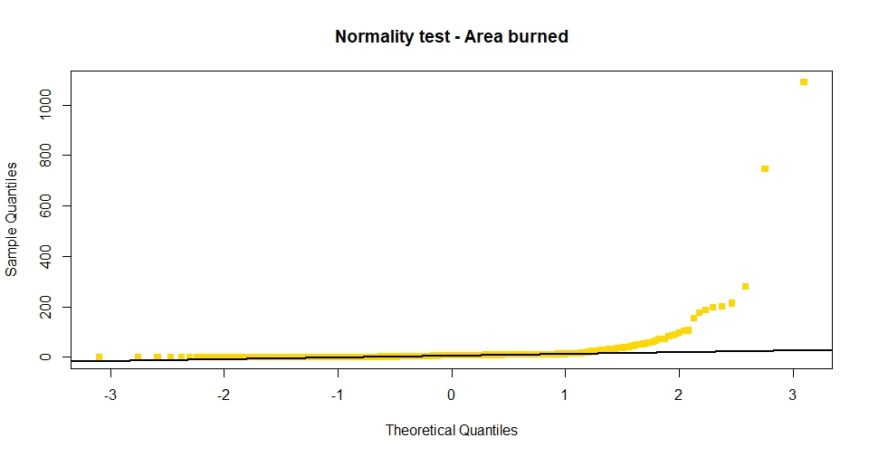

A screenshot of all the code used to obtain the normality plots is provided below:

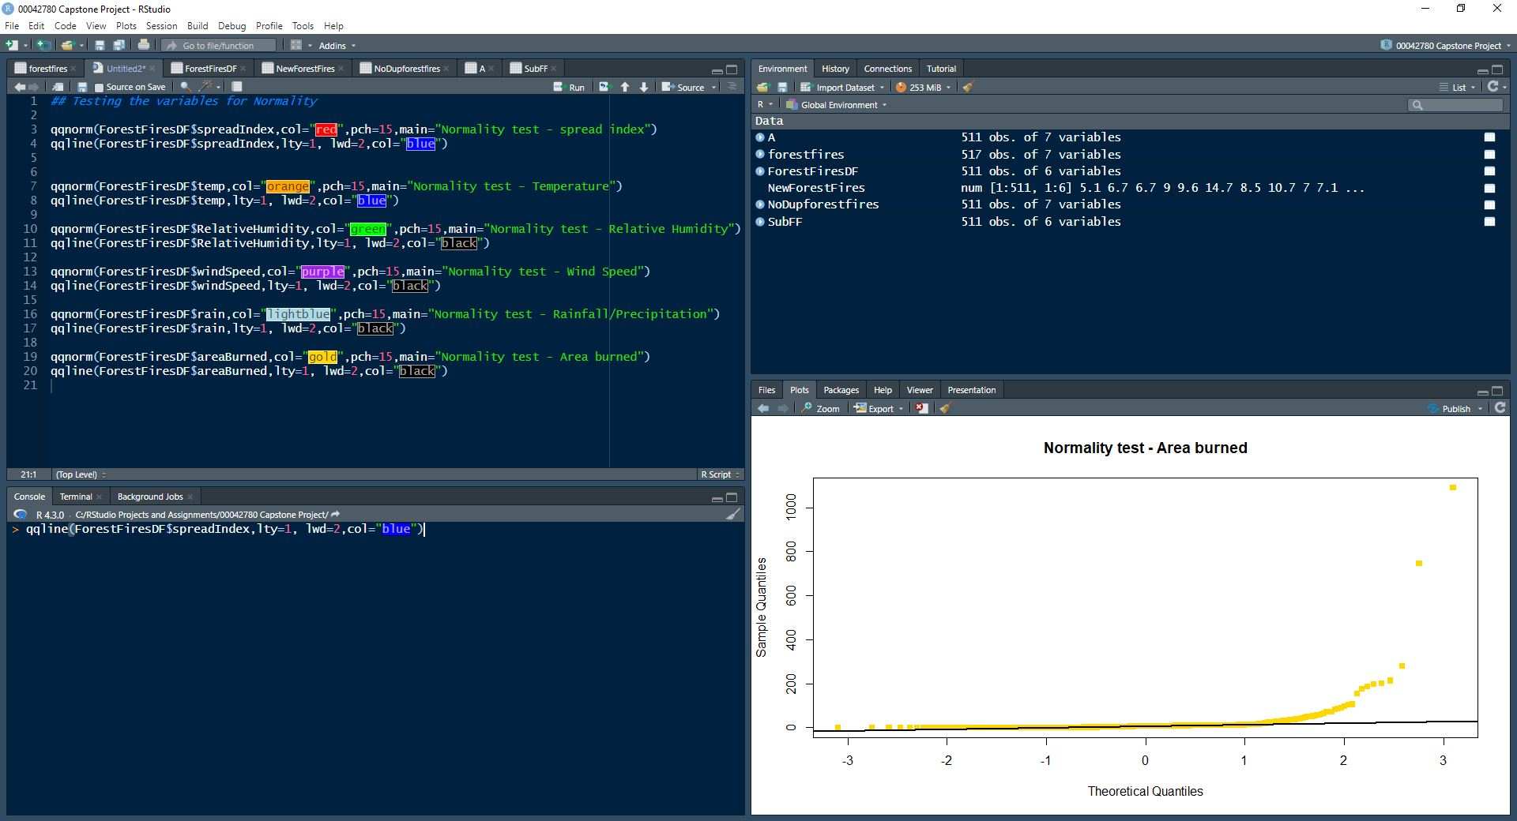

With the exception of the Relative Humidity variable, all other variables appear to be normally distributed, however, even though these variables only **appear to be normally distributed**, the next test will let us know for certain whether or not the variables are actually normally distributed.

**The Shapiro Test for Normality**

This is a hypothesis test. An important point to note is that the result of this test is that the closer our obtained p-values are to 0.05, the more normal the variable is.

This test is done on each variable using the following lines of code:

shapiro.test(ForestFiresDF$spreadIndex)

shapiro.test(ForestFiresDF$temp)

shapiro.test(ForestFiresDF$RelativeHumidity)

shapiro.test(ForestFiresDF$windSpeed)

shapiro.test(ForestFiresDF$rain)

shapiro.test(ForestFiresDF$areaBurned)

Results obtained as follows:

***Spread index***

Shapiro-Wilk normality test

data: ForestFiresDF$spreadIndex

W = 0.86443, p-value < 2.2e-16

***Temperature***

Shapiro-Wilk normality test

data: ForestFiresDF$temp

W = 0.98661, p-value = 0.0001223

***Relative Humidity***

Shapiro-Wilk normality test

data: ForestFiresDF$RelativeHumidity

W = 0.94467, p-value = 7.071e-13

***Wind speed***

Shapiro-Wilk normality test

data: ForestFiresDF$windSpeed

W = 0.96736, p-value = 3.07e-09

***Rain***

Shapiro-Wilk normality test

data: ForestFiresDF$rain

W = 0.089886, p-value < 2.2e-16

***Area burned***

Shapiro-Wilk normality test

data: ForestFiresDF$areaBurned

W = 0.17874, p-value < 2.2e-16

In light of the above, none of the variables are normally distributed since the p-values are close a lot smaller than 0.05.

**Chi plot Test for Independence**

The chi plot test is done in pairs. There are 6 variables. Using a simple nCr function, there are 15 pairs that can be obtained from this data set (6Choose2), however, because the main variable of concern is the area burned,(**Our “dependent variable”**) we shall conduct the chi plot test using the following pairs: Spread Index vs Area burned, temp vs area burned, relative humidity vs area burned, wind speed vs area burned and rain vs area burned.

Essentially we are trying to determine how dependent the area burned variable is on the following variables: spread index, temperature, relative humidity, wind speed and rainfall. Our chi plots are constructed using the following lines of code:

**Spread Index vs Area burned.**

chiplot(ForestFiresDF$spreadIndex,ForestFiresDF$areaBurned,

main="Chiplot of Spread Index and Area burned",col="green",pch=16)

**Temperature vs Area burned.**

chiplot(ForestFiresDF$temp,ForestFiresDF$areaBurned,

main="Chiplot of temperature and Area burned",col="red",pch=16)

**Relative Humidity vs Area burned.**

chiplot(ForestFiresDF$RelativeHumidity,ForestFiresDF$areaBurned,

main="Chiplot of Relative Humidity and Area burned",col="orange",pch=16)

**Wind speed vs Area burned.**

chiplot(ForestFiresDF$windSpeed,ForestFiresDF$areaBurned,

main="Chiplot of wind speed and Area burned",col="blue",pch=16)

**Rainfall vs Area burned.**

chiplot(ForestFiresDF$rain,ForestFiresDF$areaBurned,

main="Chiplot of rain and Area burned",col="purple",pch=16)

The plots obtained are as follows:

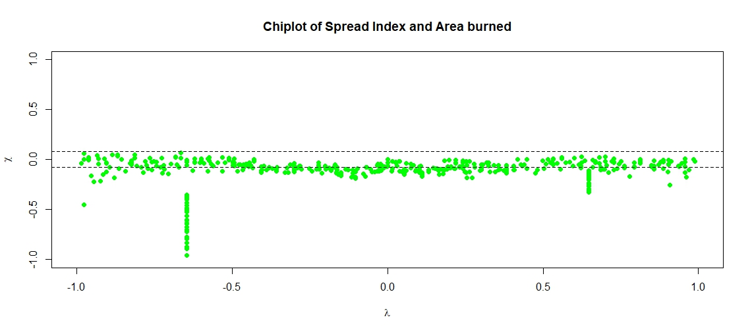

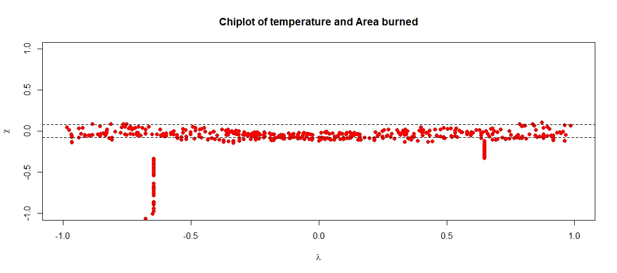

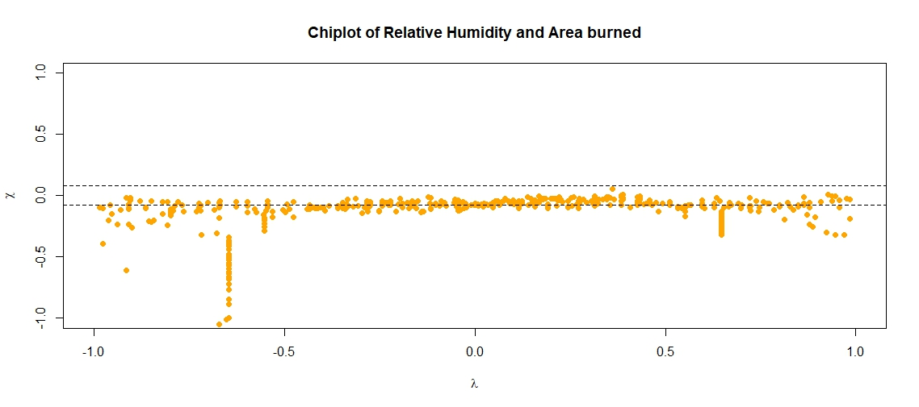

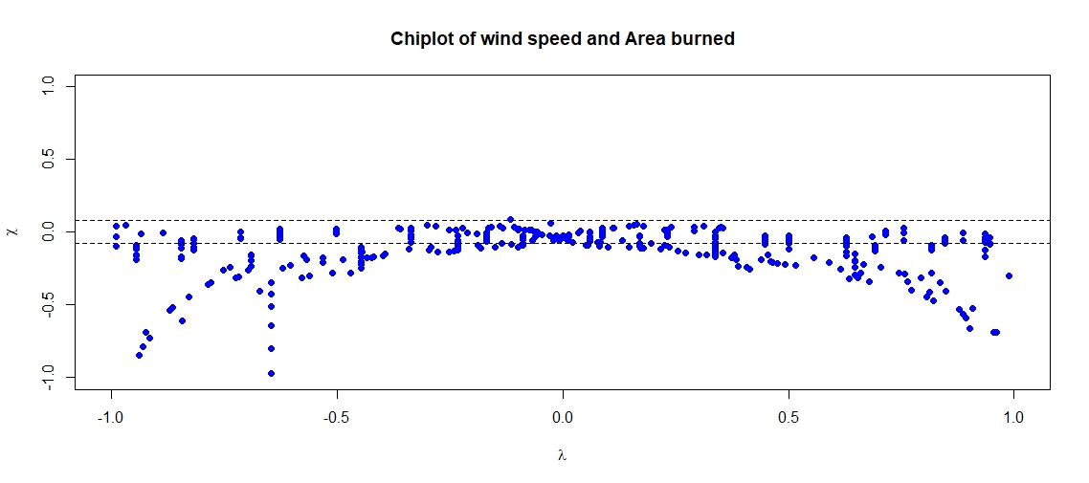

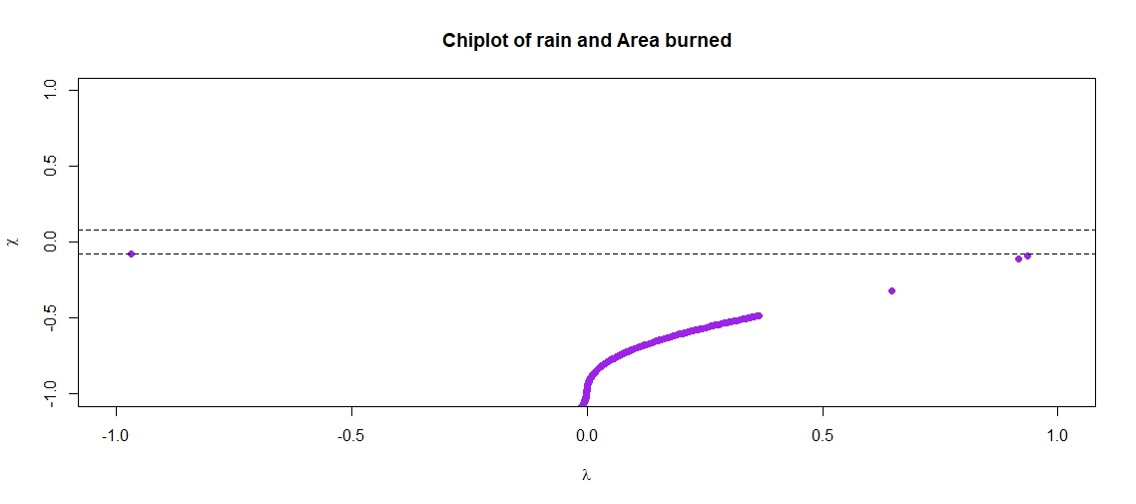

The interpretation of chi plots is such that the greater the number of points outside of the bar, the more dependent the variables are on each other. More on this in the discussion section of this report.

**Chi Square/Hypothesis Tests**

We now do hypothesis tests to validate the chi plots obtained above. This is done by first importing the MASS library. Code used is as follows:

tbl<-table(ForestFiresDF$spreadIndex, ForestFiresDF$areaBurned)

chisq.test(tbl)

Results as follows:

Pearson's Chi-squared test

data: tbl

X-squared = 44396, df = 45934, p-value = 1

Chi-squared

The following lines of code are used to obtain the required results of our respective hypothesis tests:

**Temperature**

tbl<-table(ForestFiresDF$temp, ForestFiresDF$areaBurned)

chisq.test(tbl)

**Relative Humidity**

tbl<-table(ForestFiresDF$RelativeHumidity, ForestFiresDF$areaBurned)

chisq.test(tbl)

**Wind Speed**

tbl<-table(ForestFiresDF$windSpeed, ForestFiresDF$areaBurned)

chisq.test(tbl)

**Rainfall**

tbl<-table(ForestFiresDF$rain, ForestFiresDF$areaBurned)

chisq.test(tbl)

Results obtained as follows:

***Temperature:***

Pearson's Chi-squared test

data: tbl

X-squared = 74125, df = 74112, p-value = 0.4861

***Relative Humidity:***

Pearson's Chi-squared test

data: tbl

X-squared = 74125, df = 74112, p-value = 0.4861

***Wind Speed:***

Pearson's Chi-squared test

data: tbl

X-squared = 8636, df = 8106, p-value = 2.247e-05

***Rainfall:***

Pearson's Chi-squared test

data: tbl

X-squared = 1479.1, df = 3860, p-value = 1

p-values less than 0.05 indicate that the variables are dependent on each other.

**Covariance, Correlation and Distance**

We begin by finding the covariance matrix. It must be noted that the covariance matrix is found by using a data set which contains only numeric variables. (As a reminder, our two main data frames being used as we move forward are A and ForestFiresDF. A contains all the columns and has no NA’s nor repetition. ForestFiresDF contains no repetitions, no NAs and it also does not contain the month column.)

We shall find the covariance matrices using the cov function. We find the covariance matrix of ForestFiresDF as follows:

cov(ForestFiresDF)

Output as follows:

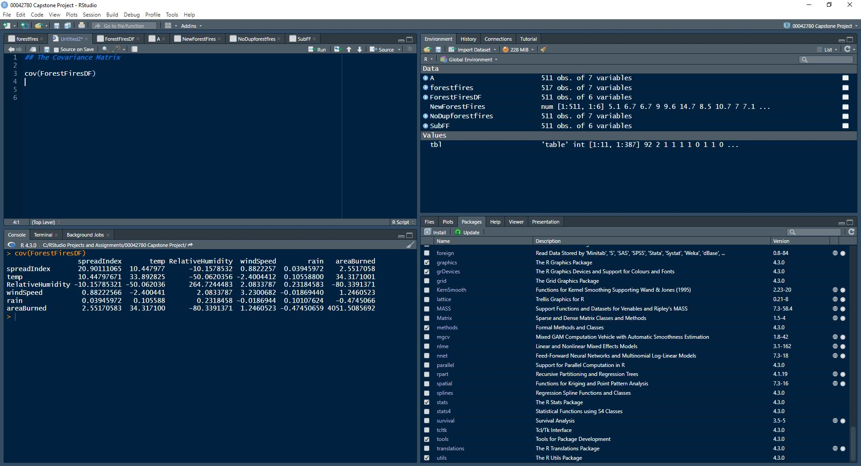

Let us now find the covariance matrix using a single column. In this particular case let’s look at sorting these matrices by month (The categorical data type).Let us do this by looking at a some of the months. (March, June, September and December)

***March:***

Code used: cov(subset(A,NoDupforestfires$month=="3")[ ,c(2:7)])

Output:

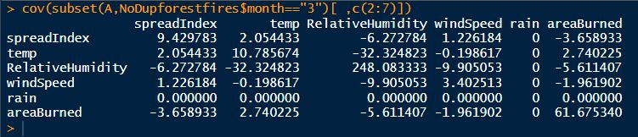

***June:***

Code used: cov(subset(A,NoDupforestfires$month=="6")[ ,c(2:7)])

Output:

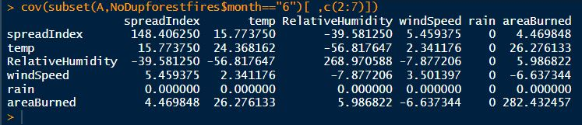

***September:***

Code used: cov(subset(A,NoDupforestfires$month=="9")[ ,c(2:7)])

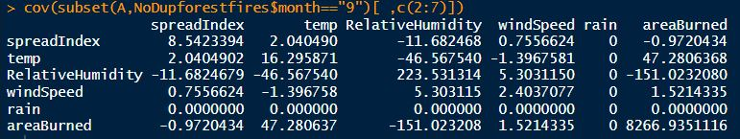

***December:***

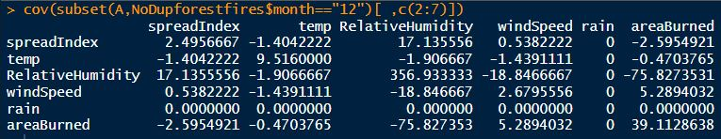

We now proceed to find the Euclidean **Distance matrix**, which gives us the distance from each point to every OTHER point.

Let us call this matrix DistForestFires. Code used is as follows:

DistForestFires<-dist(scale(ForestFiresDF))

Now even though we can’t use the view function on this distance matrix, we can still see a part of this matrix. Let us look at a 6x6 sub-matrix of DistForestFires. It should be noted that this matrix is very large, as stated in the Global Environment window, 130305 elements.

Using the following code:

as.dist(round(as.matrix(DistForestFires),2 [1:6, 1:6])

Output as follows:

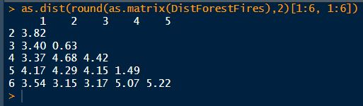

**Further Data Visualization**

Let us now gain some more insight into our data set by using more exploratory graphs, namely, **Histograms, Boxplots and Barplots**. These plots will be looked at in the discussion.

We begin by looking at a summary of our data frame named A. This data frame is free of errors and NAs. This data frame also contains all the columns of the originally provided data set.

Code used:

summary(A)

Output as follows:

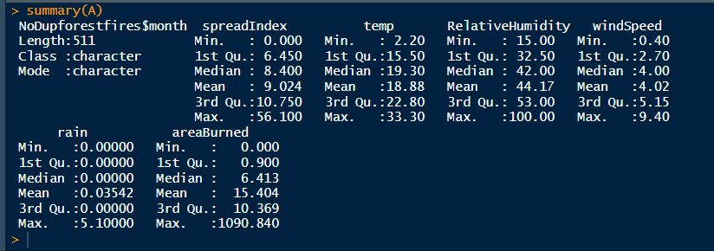

Apart from the Mean, the screenshot above provides a 5 number summary of each numeric variable.

**Histograms**

We now proceed to create Histograms with rugplots for each of the numerical variables using the following lines of code and the ForestFiresDF data frame. (The data frame A could have also been used as we are using only numerical variables)

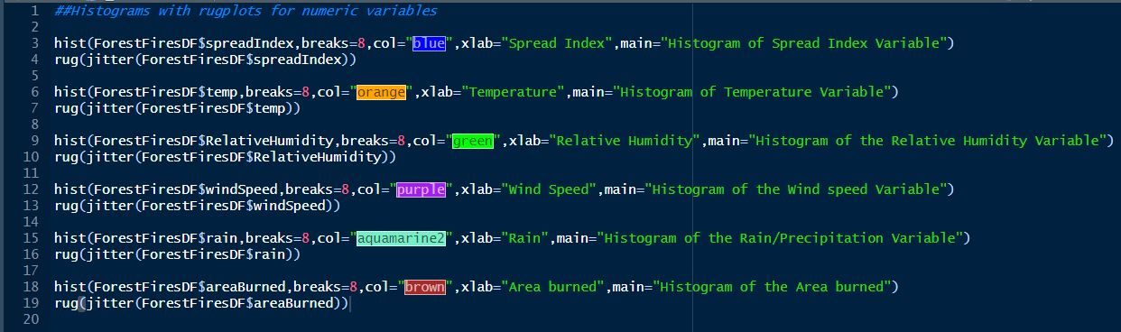

Outputs below:

***spreadIndex:***

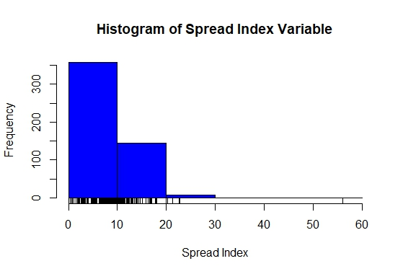

***temperature:***

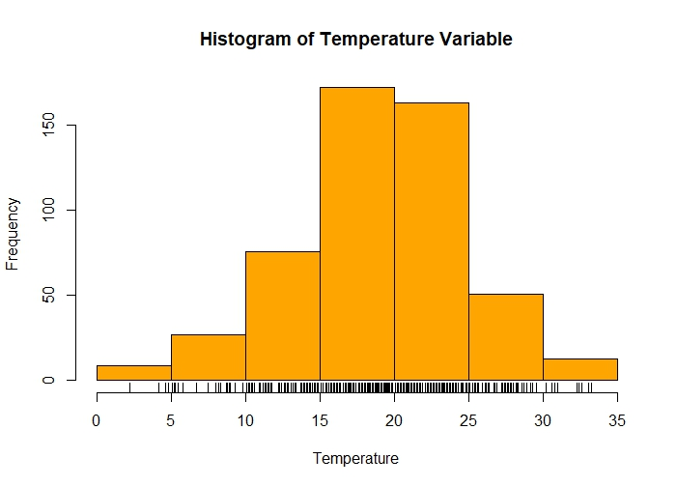

***Relative Humidity:***

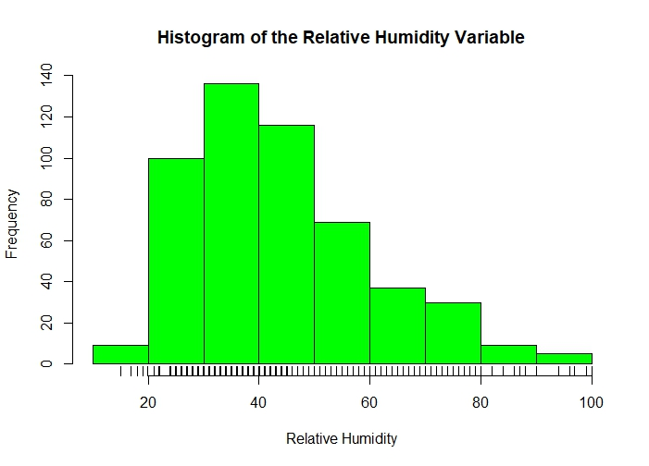

***Wind speed:***

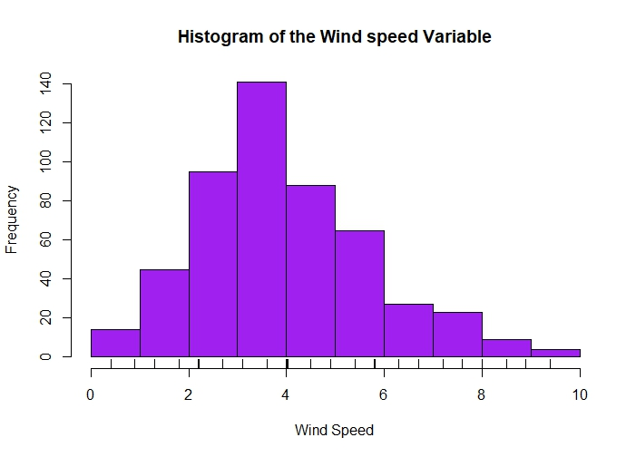

***Rain:***

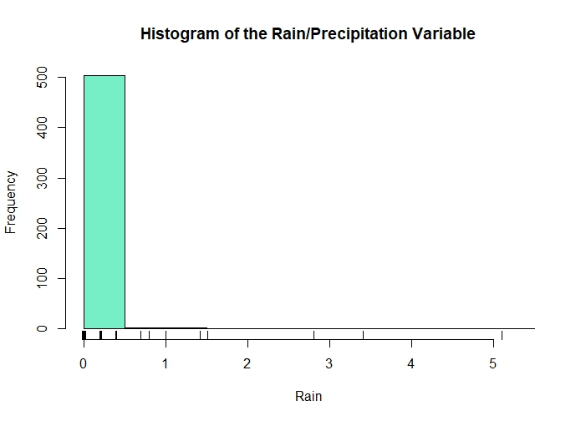

***Area burned:***

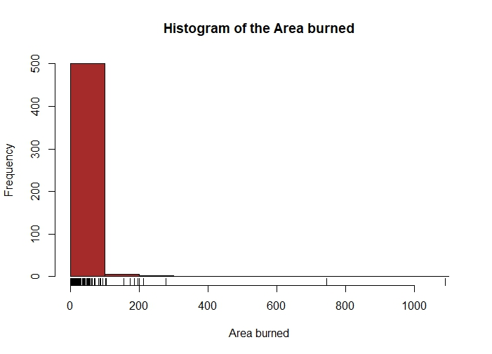

**Boxplots**

Boxplots were constructed using the following lines of code:

boxplot(A$spreadIndex,xlab="Spread Index",main="Boxplot of Spread Index Variable",col="blue")

boxplot(A$temp,xlab="Temperature",main="Boxplot of the temperature Variable",col="orange")

boxplot(A$RelativeHumidity,xlab="Relative Humidity",main="Boxplot of the Relative humidity Variable",col="green")

boxplot(A$windSpeed,xlab="Wind speed",main="Boxplot of the wind speed Variable",col="purple")

boxplot(A$rain,xlab="Rainfall",main="Boxplot of the Rainfall Variable",col="aquamarine")

boxplot(A$areaBurned,xlab="Area burned",main="Boxplot of the area burned Variable",col="brown")

***Spread Index:***

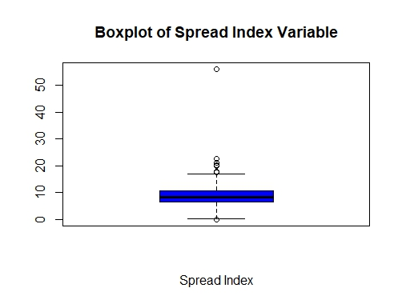

***Temperature:***

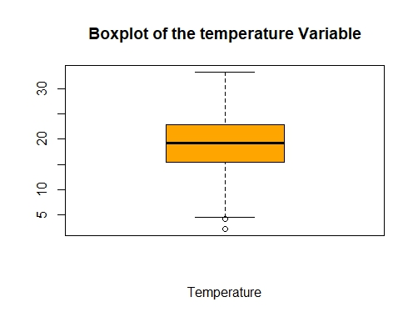

***Relative Humidity:***

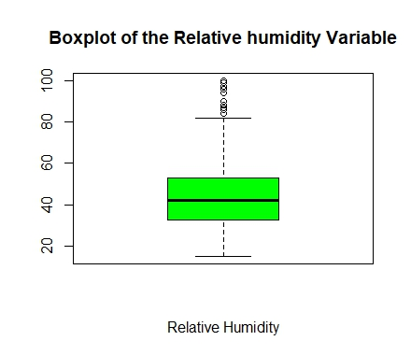

***Wind speed:***

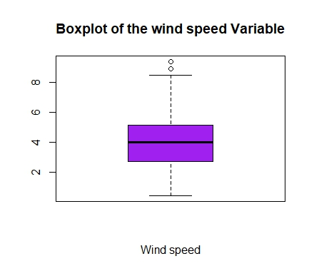

***Rain:***

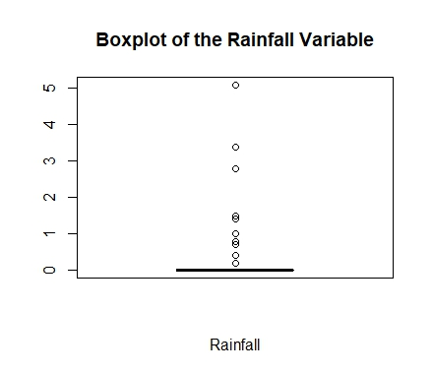

***Area burned:***

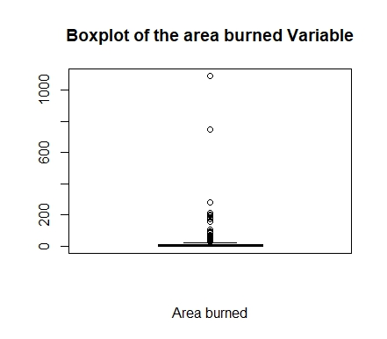

**Bar plots**

We use bar plots to visualize categorical data. Our months make up our categorical variables. Let us begin by first determining how much of our data corresponds to each month.

Code used:

counts<-table(A$`NoDupforestfires$month`)

counts

Output:

> counts<-table(A$`NoDupforestfires$month`)

> counts

1 10 11 12 2 3 4 5 6 7 8 9

3 3 12 10 20 48 9 3 17 32 192 162

Essentially the output is showing us how many rows of data correspond to each month. The corresponding bar plot is as follows:

In the code above we use 12 to represent each month as there are 12 months in a year. Code and output as below:

barplot(counts,main="Barplot of Months variable",xlab="Frequency",horiz="TRUE",col="rainbow"(12))

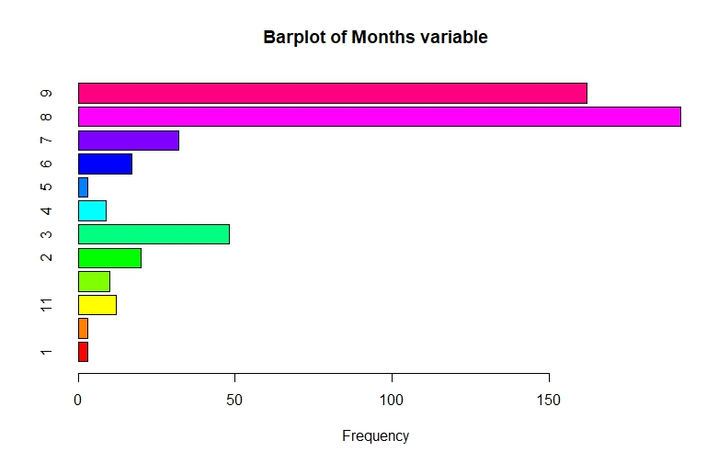

We now look at Bivariate plots. Bivariate plots being used include Scatterplots and 3D Scatterplots.

**Scatterplots**

To begin with, scatterplots require the use of two packages; gclus and scatterplot3d. These packages would have already been downloaded and installed. Because our variable of focus is the area burned, the following Scatterplots will be done:

Area burned vs months.

Area burned vs Spread Index

Area burned vs temperatures.

Area burned vs Relative Humidity

Area burned vs Wind Speed

Area burned vs Rainfall.

These scatterplots will be done in pairs as side-by-side plots. Plots are done by first attaching the data frame being used (In this case we are using A).

Code to be used:

View(A)

## SCATTER PLOTS

attach(A)

plot(spreadIndex,areaBurned,main="Basic scatterplot of Area burned vs Spread Index",xlab="Spread index",ylab="Area burned",pch=19,col="blue")

points(spreadIndex,temp,col="red",pch=16)

legend(locator(1),c("Area Burned","Temperature"),pch=c(19,16),col=c("blue","red"))

opar<-par(no.readonly=TRUE)

par(mfrow=c(1,2))

plot(`NoDupforestfires$month`,areaBurned,col="blue",pch=15,xlab="Months",ylab="Area burned")

plot(spreadIndex,areaBurned,col="red",pch=16,xlab="Spread Index",ylab="Area burned")

opar<-par(no.readonly=TRUE)

par(mfrow=c(1,2))

plot(temp,areaBurned,col="orange",pch=15,xlab="Temperature",ylab="Area burned")

plot(RelativeHumidity,areaBurned,col="green",pch=16,xlab="Relative humidity",ylab="Area burned")

opar<-par(no.readonly=TRUE)

par(mfrow=c(1,2))

plot(windSpeed,areaBurned,col="purple",pch=15,xlab="Wind speed",ylab="Area burned")

plot(rain,areaBurned,col="aquamarine",pch=16,xlab="Rainfall",ylab="Area burned")

Outputs:

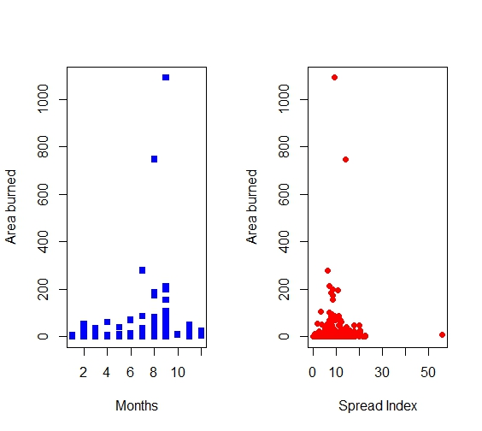

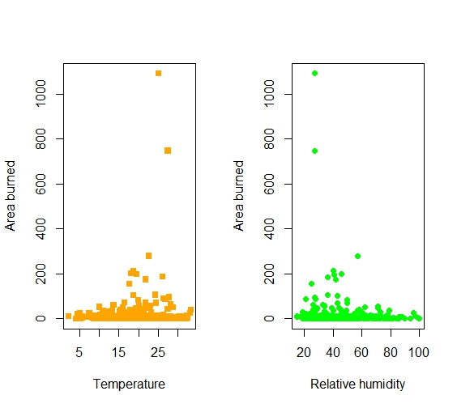

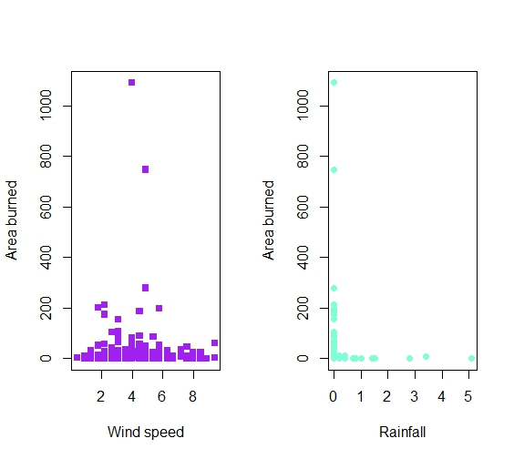

The beauty of R is that it enables us to look at a data set from multiple perspectives. Being able to look at a single data set from multiple perspectives gives us greater and greater insight into what the data is telling us. Let us now proceed to do some side-by-side box plots.

Recall: Box plots are non-numeric against numeric. We must however create a factor for the months (Categorical data type)

Code to be used:

par(mfrow=c(1,1)) ## This line of code is used to reset the plots so that

##they are no longer side-by side

Months<-factor(NoDupforestfires$month)

plot(Months,areaBurned,ylab="Area burned",xlab="Months",col="rainbow"(12))

Output:

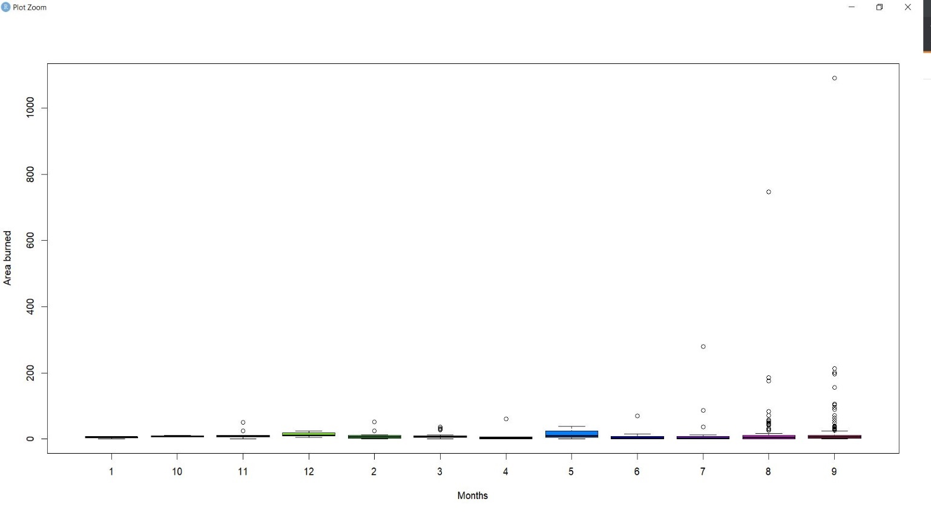

As seen above, there are many outliers in August and September.

Let us now proceed to build a few scatterplot matrices. For these matrices, we will use the following sets of variables and create corresponding sub data frames of A, named Data1 to Data3 respectively. The gclus and scatterplot3d packages have already been installed.

Spread Index, Temperature, Area burned.

Relative Humidity, Wind speed, Area burned.

Wind speed, Rain, Area burned.

Code as follows:

## Scatterplot Matrix for Data1

## Spread Index,temperature, area burned

Data1<-A[c(2,3,7)]

Data1.corr<-abs(cor(Data1))

Colors<-dmat.color(Data1.corr)

Orderings<-order.single(Data1.corr)

cpairs(Data1,Orderings,panel.colors = Colors,gap=5,main="Scatterplot Matrix of Data1 Ordered and Colored by Correlation")

##Scatterplot Matrix for Data2

Data2<-A[c(4,5,7)]

Data2.corr<-abs(cor(Data2))

Colors<-dmat.color(Data2.corr)

Orderings<-order.single(Data2.corr)

cpairs(Data2,Orderings,panel.colors = Colors,gap=5,main="Scatterplot Matrix of Data2 Ordered and Colored by Correlation")

##Scatterplot Matrix for Data3

Data3<-A[c(5,6,7)]

Data3.corr<-abs(cor(Data3))

Colors<-dmat.color(Data3.corr)

Orderings<-order.single(Data3.corr)

cpairs(Data3,Orderings,panel.colors = Colors,gap=5,main="Scatterplot Matrix of Data3 Ordered and Colored by Correlation")

Outputs as follows:

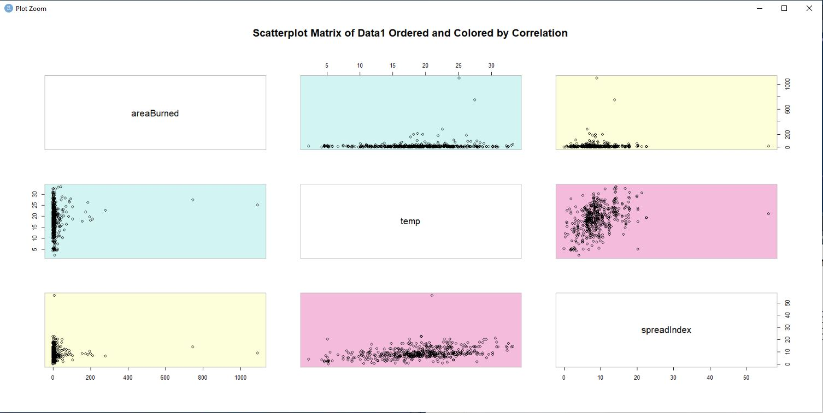

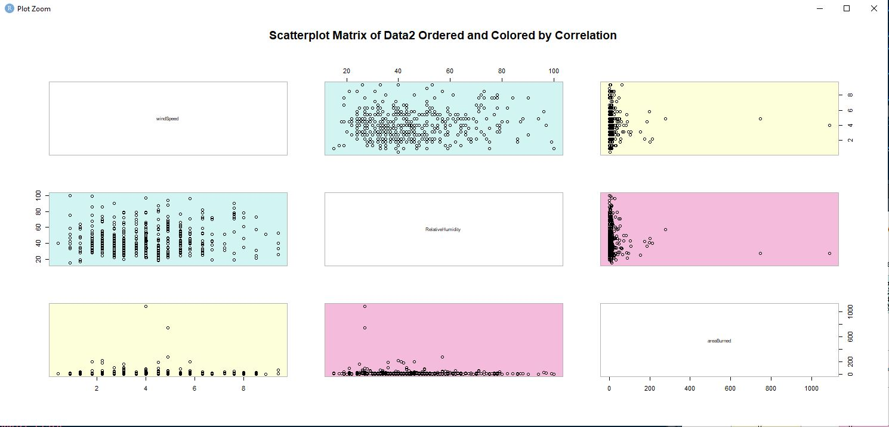

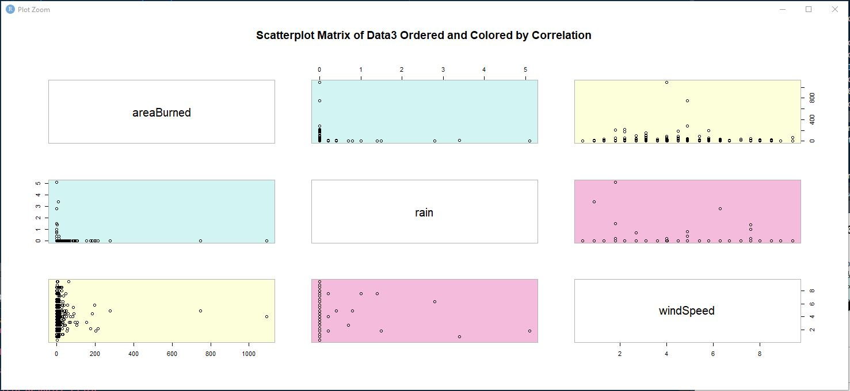

More on these plots in the discussion.

Let us now take things to the third dimension and make some 3D Scatterplots of the matrices we obtained above. We shall also add depth lines to our plots.

Code to be used as follows:

## 3D Scatterplot Matrices

attach(Data1)

scatterplot3d(temp,spreadIndex,areaBurned,main="3-D Scatterplot of the variables of Data1",highlight.3d=TRUE,pch=15,type="h")

attach(Data2)

scatterplot3d(RelativeHumidity,windSpeed,areaBurned,main="3-D Scatterplot of the variables of Data2",highlight.3d=TRUE,pch=15,type="h")

attach(Data3)

scatterplot3d(windSpeed,rain,areaBurned,main="3-D Scatterplot of the variables of Data3",highlight.3d=TRUE,pch=15,type="h")

Outputs as follows:

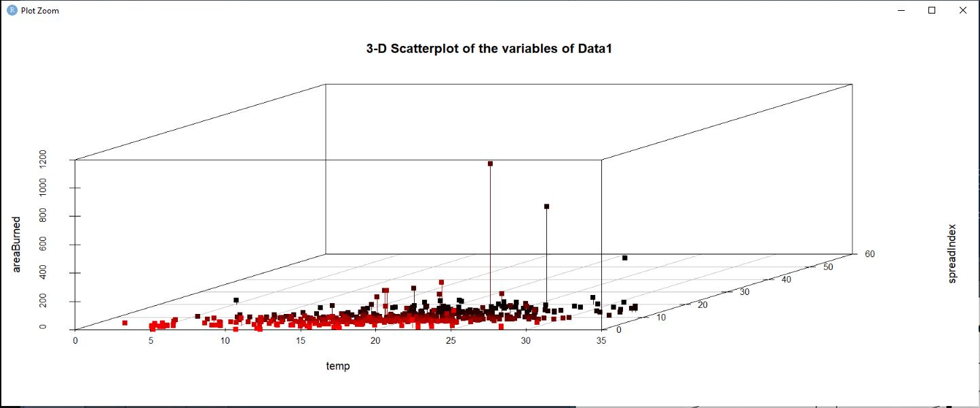

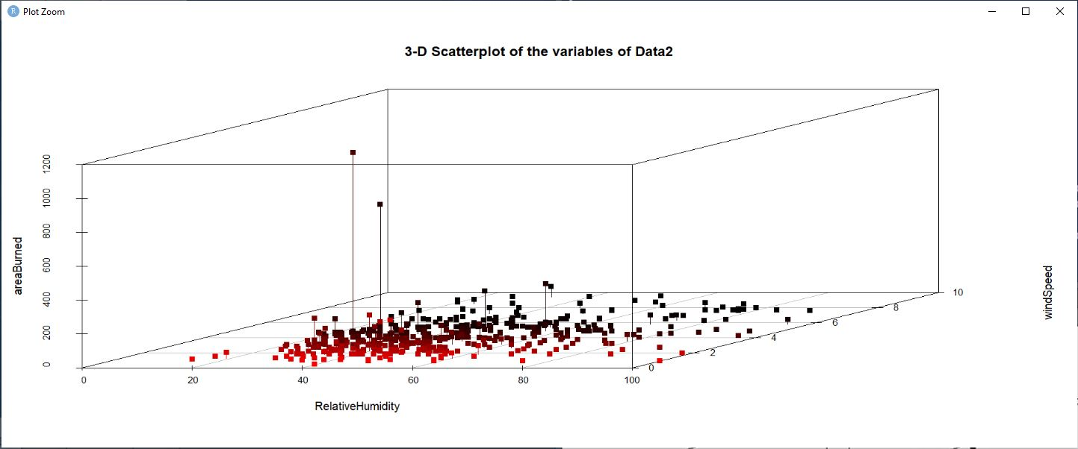

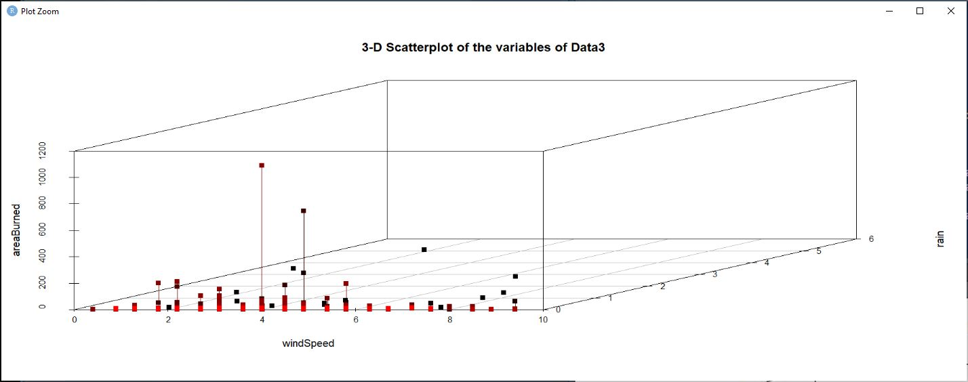

**Graphical Tests for Multivariate Normality**

Multivariate normality is tested using Chi plots. Further to this, we’ll build some relationship plots (Bubble plots and Panel plots)

The first set of plots are being done with a line being used to represent the chisquare quartile. The closer the points to the line, the more normally distributed the variables.

Code used:

## Multivariate Normality

cm<-colMeans((Data1))

cm

Data1covmat<-cov(Data1)

d<-apply(Data1,1,function(Data1)t(Data1-cm)%*%solve(Data1covmat)%*%(Data1-cm))

plot(Qc<-qchisq((1:nrow(Data1)-1/2)/nrow(Data1),df=3),sd<-sort(d),xlab=expression(paste(chi[4]^2,"Quantile")),

ylab="Ordered distances",xlim=range(Qc)*c(1,1.1),col="red",pch=16,main="Multivariate chiplot of Data1")

abline(a=0,b=1,col="blue")

##Data1 seems Normally distributed

cm2<-colMeans((Data2))

cm2

Data2covmat<-cov(Data2)

e<-apply(Data2,1,function(Data2)t(Data2-cm2)%*%solve(Data2covmat)%*%(Data2-cm2))

plot(Qc<-qchisq((1:nrow(Data2)-1/2)/nrow(Data2),df=3),sd<-sort(e),xlab=expression(paste(chi[4]^2,"Quantile")),

ylab="Ordered distances",xlim=range(Qc)*c(1,1.1),col="orange",pch=16,main="Multivariate chiplot of Data2")

abline(a=0,b=1,col="blue")

#Data2 seems Normally Distributed

cm3<-colMeans((Data3))

cm3

Data3covmat<-cov(Data3)

f<-apply(Data3,1,function(Data3)t(Data3-cm3)%*%solve(Data3covmat)%*%(Data3-cm3))

plot(Qc<-qchisq((1:nrow(Data3)-1/2)/nrow(Data3),df=3),sd<-sort(f),xlab=expression(paste(chi[4]^2,"Quantile")),

ylab="Ordered distances",xlim=range(Qc)*c(1,1.1),col="purple",pch=16,main="Multivariate chiplot of Data3")

abline(a=0,b=1,col="red")

#Data3 seems Normally distributed

Outputs:

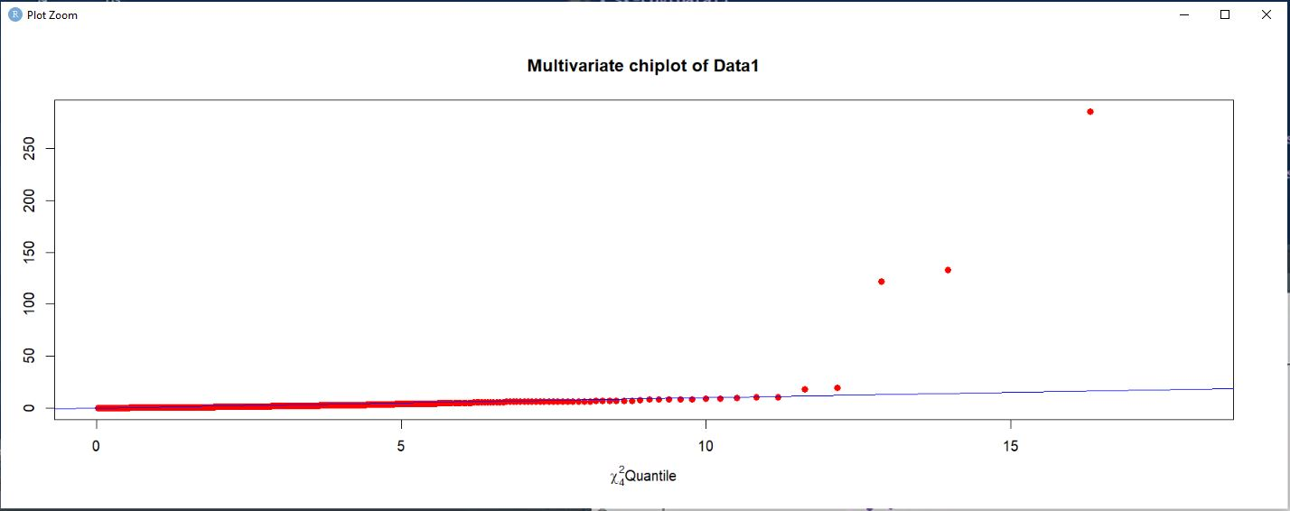

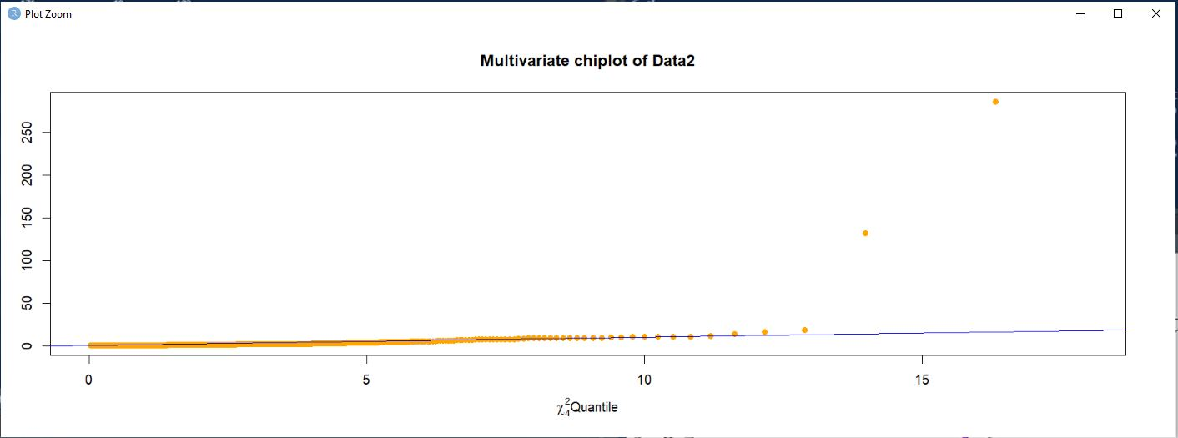

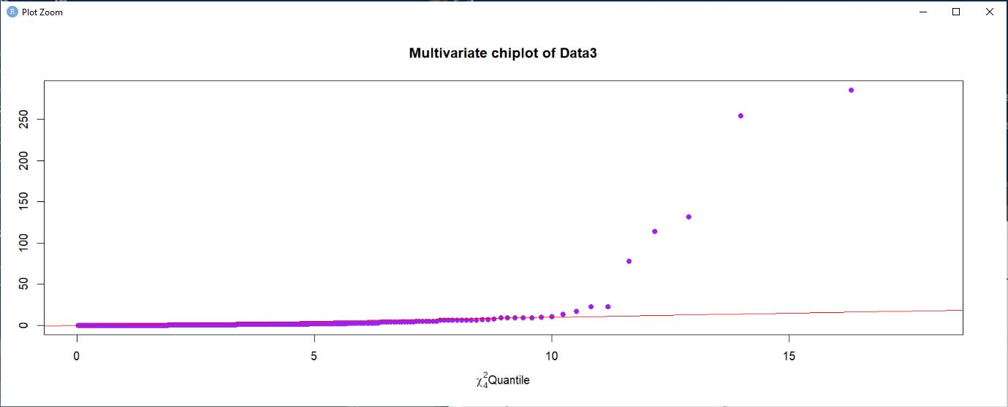

**Identifying and Confirming Outliers**

Another important aspect of Data analysis is to identify and confirm outliers in our data set. This is done using the Bivariate boxplot and the Mahalanobis distance techniques. For this we shall use our ForestFiresDF data frame which only contains numeric variables. For this we need the MVA package, which should have already been installed. Because we are doing Bivariate boxplots, we are using pairs of variables. There are 6 columns, which implies 6C2. This means that there are 15 different Bivariate plots that can be done. For this exercise, we’ll use plots with the Area burned as one of our variables. We first created matrices called BiMat1 to BiMat3. Zoom functions were used to get a closer look at the plots.

Code as follows:

BiMat1<-as.matrix(ForestFiresDF[ ,c(6,1)])

View(BiMat1)

bvbox(BiMat1,main="Bivariate boxplot of Spread Index and Area burned",xlab="Spread Index", ylab="Area burned",

pch=16,col="red")

BiMat2<-as.matrix(ForestFiresDF[ ,c(6,2)])

View(BiMat2)

bvbox(BiMat2,main="Bivariate boxplot of Temperature and Area burned",xlab="Spread Index", ylab="Area burned",

pch=16,col="green")

BiMat3<-as.matrix(ForestFiresDF[ ,c(6,3)])

View(BiMat3)

bvbox(BiMat3,main="Bivariate boxplot of Spread Index and Area burned",xlab="Spread Index", ylab="Area burned",

pch=16,col="red")

Outputs as follows:

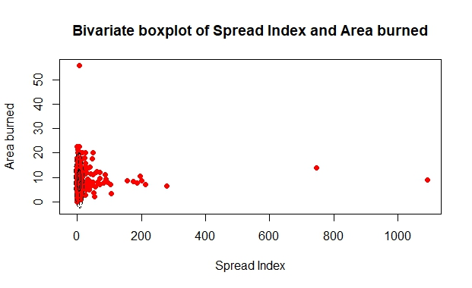

Zoomed view:

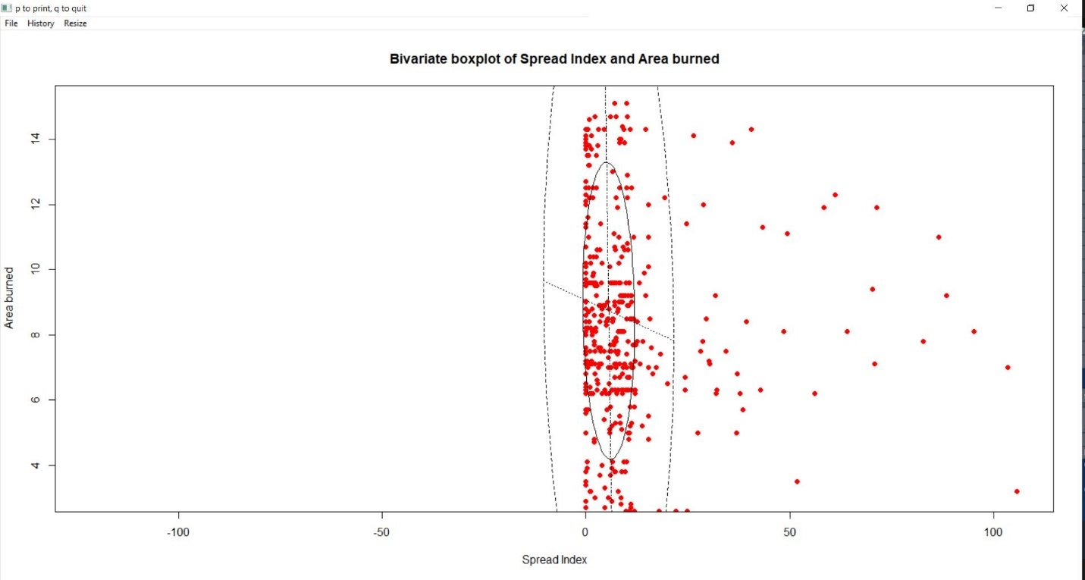

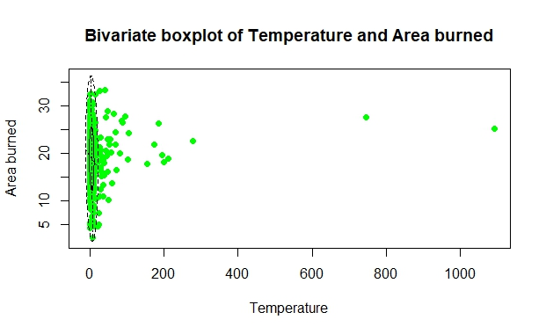

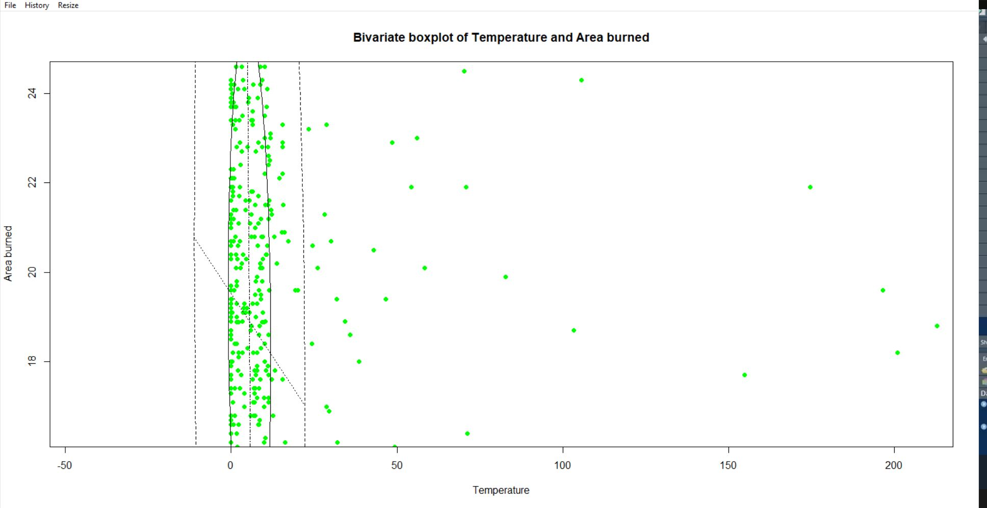

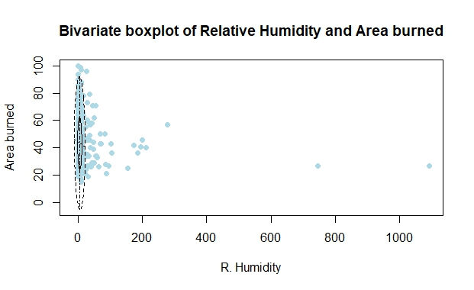

Zoomed view:

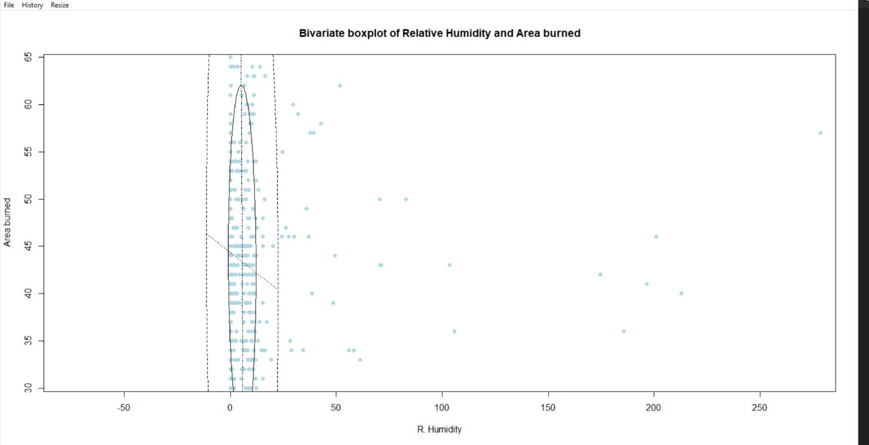

We now look at the actual outliers using the Mahalanobis Distance:

Code used:

## Matrix1

MV<-mahalanobis(BiMat1,colMeans(BiMat1),cov(BiMat1))

MV

## We need to find values greater than 9

BiMat1[MV>9, ]

##Matrix2

MV<-mahalanobis(BiMat2,colMeans(BiMat2),cov(BiMat2))

MV

BiMat2[MV>9, ]

Outputs:

|  |
| --- |
| **areaBurned spreadIndex** |
| [1,] 7.272433 56.100000 |
| [2,] 212.880000 7.000000 |
| [3,] 1090.840000 9.024063 |
| [4,] 0.170000 22.700000 |
| [5,] 746.280000 13.900000 |
| [6,] 278.530000 6.400000 |

BiMat2[MV>9, ]

|  |
| --- |
| **areaBurned temp** |
| [1,] 212.88 18.8 |
| [2,] 1090.84 25.1 |
| [3,] 746.28 27.5 |
| [4,] 278.53 22.6 |

BiMat3[MV>9, ]

|  |
| --- |
| **areaBurned RelativeHumidity** |
| [1,] 11.241768 97 |
| [2,] 6.929212 99 |
| [3,] 26.000000 96 |
| [4,] 212.880000 40 |
| [5,] 1090.840000 27 |
| [6,] 0.000000 94 |
| [7,] 0.000000 100 |
| [8,] 746.280000 27 |
| [9,] 278.530000 57 |

The above tables represent the outliers for the matrices created (BiMat1, BiMat2, BiMat3)

**Relationship Plots**

These take the form of Panel plots and bubble plots. We’ll do some panel plots as follows:

(The Lattice package would have already been installed). For these plots, we use the previously created sub frames, Data1, Data2 and Data3.

Code used:

attach(Data1)

plot(xyplot(temp~spreadIndex|cut(areaBurned,3),data=Data1,col="green",pch=15,main="Panel plot

of Area burned vs Spread Index with temperature as conditioning variable"))

attach(Data2)

plot(xyplot(windSpeed~RelativeHumidity|cut(areaBurned,3),data=Data2,col="orange",pch=15,main="Panel plot

of Area burned vs R. Humidity with wind speed as conditioning variable"))

attach(Data3)

plot(xyplot(rain~windSpeed|cut(areaBurned,3),data=Data3,col="lightblue",pch=15,main="Panel plot

of Area burned vs Wind speed with rainfall as conditioning variable"))

Outputs:

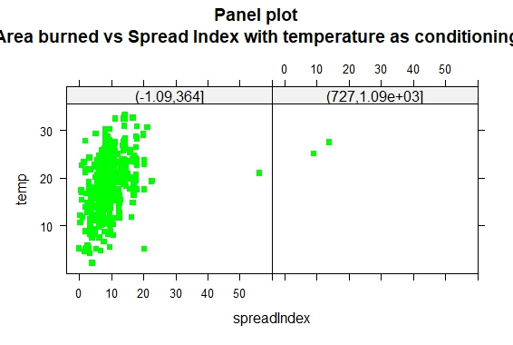

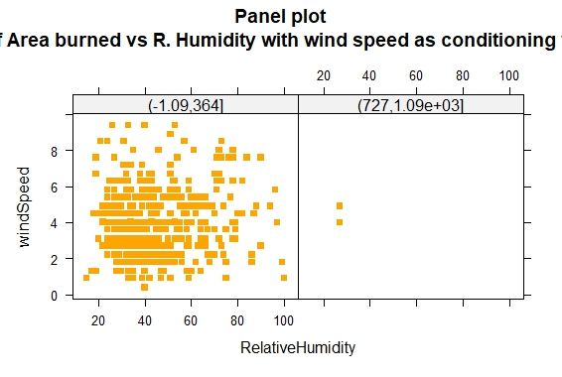

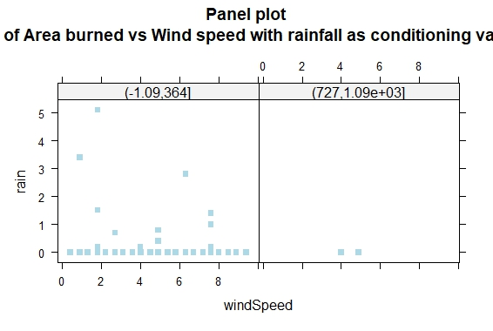

Let us now do Bubble plots of these data frames. Data1, Data2 and Data3

Code used as follows:

r<-sqrt(Data1$spreadIndex/pi)

symbols(temp,areaBurned,circle=r,inches=0.5,fg="white",bg="orange",main="Temp vs area burned with Pt Size 3 prop. to Spread Index")

q<-sqrt(Data2$RelativeHumidity/pi)

symbols(windSpeed,areaBurned,circle=r,inches=0.5,fg="white",bg="blue",main="Wind speed vs area burned with Pt Size 3 prop to R. Humidity")

b<-sqrt(Data3$windSpeed/pi)

symbols(rain,areaBurned,circle=r,inches=0.5,fg="white",bg="red",main="Rain vs area burned with Pt Size 3 prop to Wind speed")

Outputs:

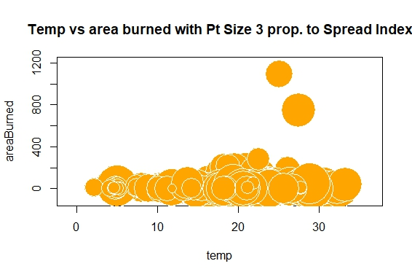

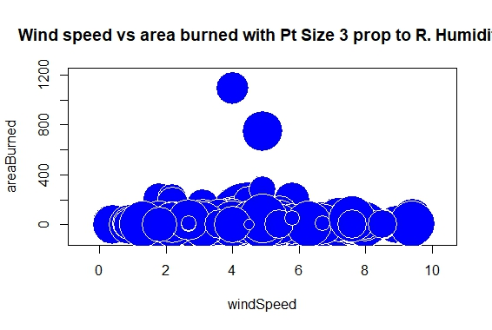

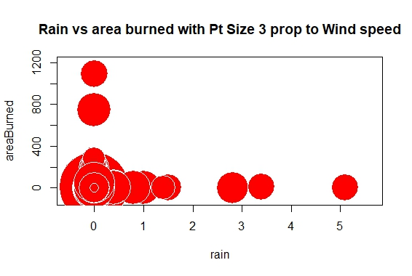

**Principal Component Analysis**

This will be the final part of the analysis section of this report. Before we continue, we need the following packages: ggplot2,GGAlly,scatterplot3d,rgl. For the purpose of PCA, we use our data frame ForestFiresDF as it only has numerical variables.

We start by obtaining a ggpairs plot to see correlation groups

Code used:

ggpairs(ForestFiresDF)

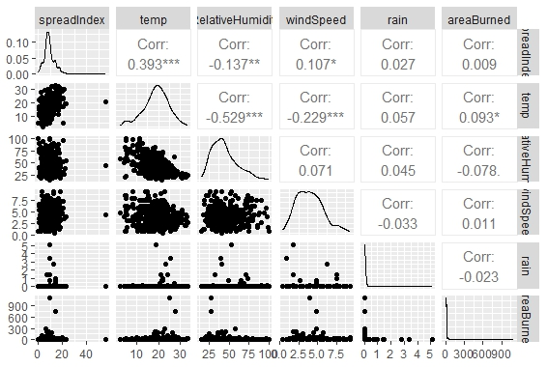

We now check for multivariate normality using the mahalanobis distance matrix.

Code used:

mahalanobis(ForestFiresDF,colMeans(ForestFiresDF),cov(ForestFiresDF))

Output:

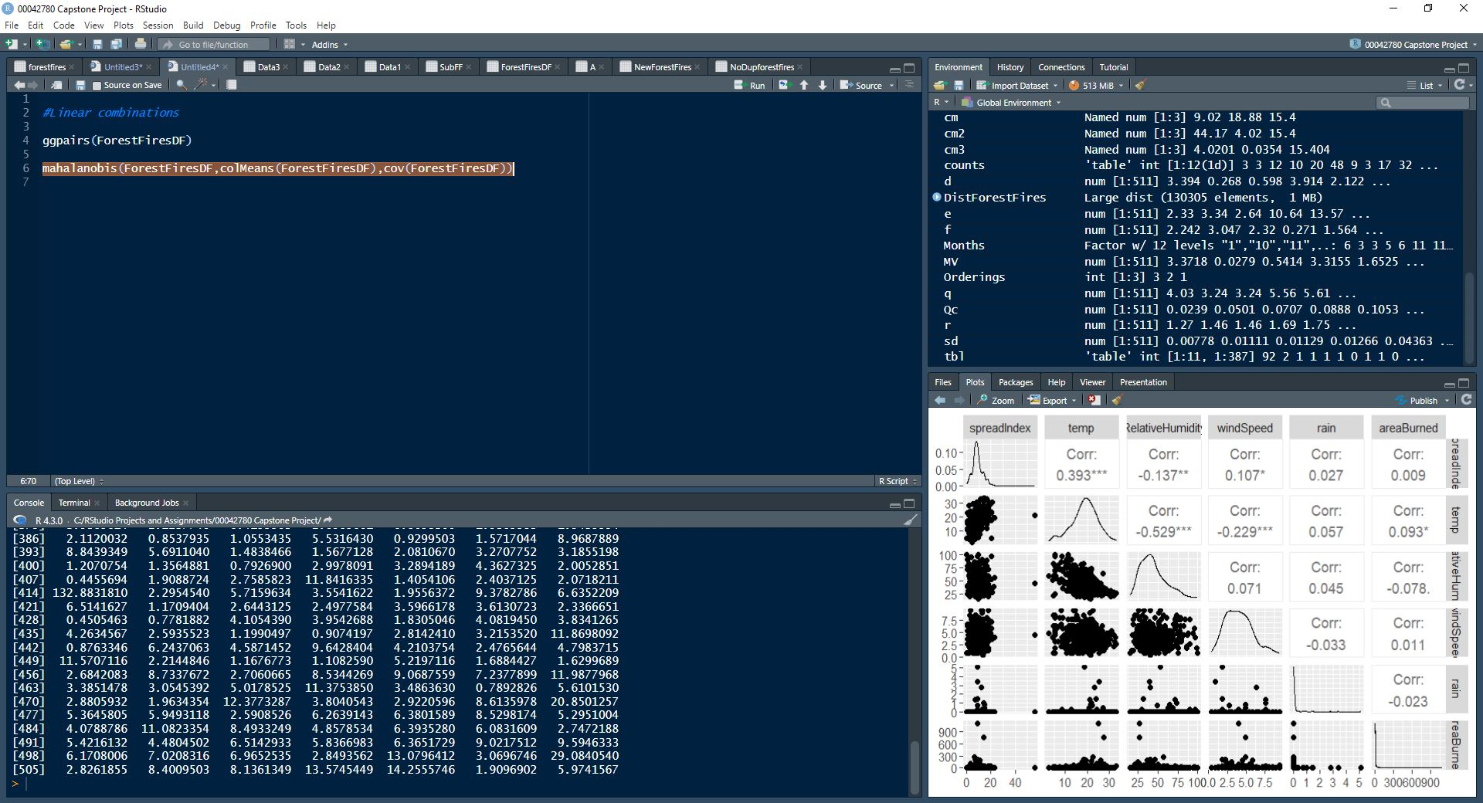

We obtained 505 observations. Let us now do a Histogram of this distance matrix.

Code used:

ggpairs(ForestFiresDF)

View(ForestFiresDF)

head(ForestFiresDF)

mahalanobis(ForestFiresDF,colMeans(ForestFiresDF),cov(ForestFiresDF))

hist(mahalanobis(ForestFiresDF,colMeans(ForestFiresDF),cov(ForestFiresDF)),

xlab="Mahalanobis Distance",col="blue",main="Histogram of Mahalanobis Distances")

Output:

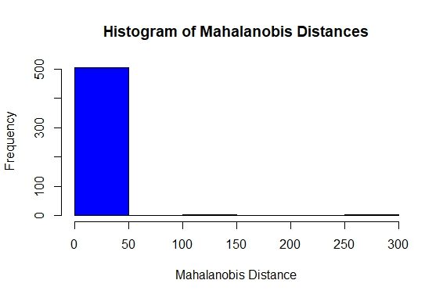

We now check for outliers.

Code used:

ForestFiresDF$maha<-mahalanobis(ForestFiresDF,colMeans(ForestFiresDF),cov(ForestFiresDF))

The code above is taking the mahalanobis distances and adding them as a column to the

ForestFiresDF dataframe

We now add the p-value column.

ForestFiresDF$p<-pchisq(ForestFiresDF$maha,df=5,lower.tail = FALSE)

View(ForestFiresDF)

We now have a data frame with p-values

To check for outliers, we use the following if statement with an index:

ind<-which.min(ForestFiresDF$p)

if(ForestFiresDF$p[ind]<0.001){print("No distance has a p-value less than 0.001")}

ind<-which.min(ForestFiresDF$p)

if(ForestFiresDF$p[ind]<0.001){print("No distance has a p-value less than 0.001")}

No outliers were found!

**Multivariate Normality**

To check for multivariate normality, we use a qqplot as follows:

qqnorm(mahalanobis(ForestFiresDF, colMeans(ForestFiresDF), cov(ForestFiresDF)), col = "red", cex = 2, pch = 19)

qqline(mahalanobis(ForestFiresDF, colMeans(ForestFiresDF), cov(ForestFiresDF)), col = "black",lwd=2)

Output as follows:

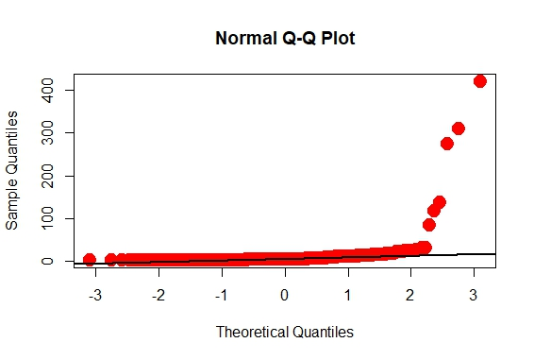

This data set is not normally distributed as there are a lot of point that aren’t running alongside the line.

**Principal Components**

We start by creating a new data frame called ForestFiresPC which contains only numerical variables, this was done by simply removing the last 2 columns from the ForestFiresDF data frame, namely, maha and p.

Code used:

ForestFiresPC<-ForestFiresDF[ ,1:6]

Doing a summary of our newest data frame:

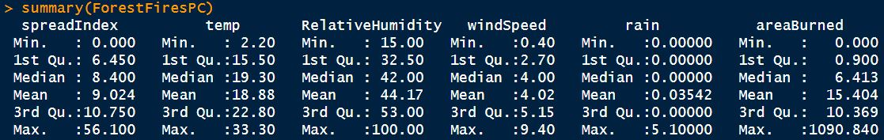

We are now creating a data frame for the principal components. We expect to see 6 Principal Components. Let us call this data frame RoysPRcomp. Let’s do a scaled plots of wind speed vs Area burned.

Code used:

RoysPRcomp<-prcomp(ForestFiresPC,scale=TRUE)

plot(scale(ForestFiresPC$windSpeed),scale(ForestFiresPC$areaBurned),xlab="Spread Index",ylab="Wind speed",col="blue",pch=16)

Output as follows:

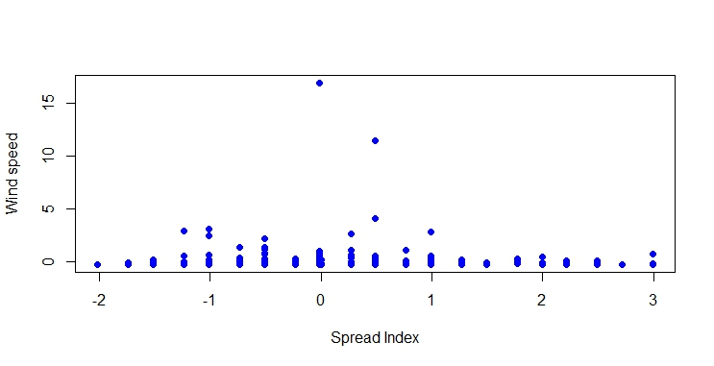

Moving onto Principal Component Analysis, let us start by calling our object RoysPRcomp:

Output as follows:

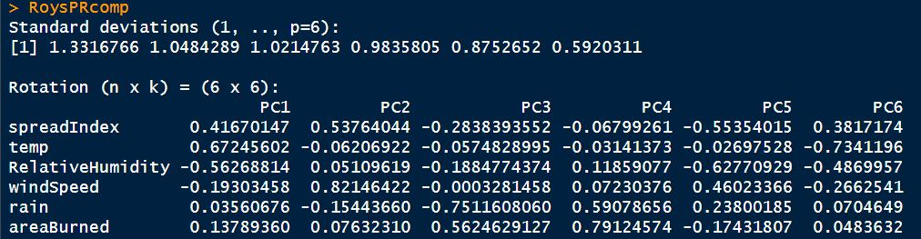

This provides us with the standard deviations of the Principal Components. The rotation represents the rotation of the axes with the principal components of the vectors. Under the PC columns in our output above are the eigenvectors.

We now obtain a summary of the Principal Component we created:

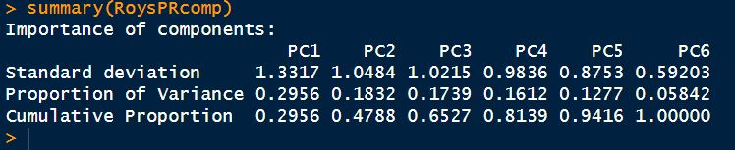

The Proportion of Variance and the Cumulative Proportion rows are basically linear combinations of the original variables. We have just obtained our Principal Components which are being used to represent the entire original data set (which is much bigger.) It should also be noted that the PCs account for different amounts of variance in descending order, ie; PC1 accounts for the largest amount of variance whilst PC6 accounts for the least. In this particular case, PC1 accounts for 29% of the variance, whilst PC6 accounts for 5.8%.

Let us now look at the proportion of variance graphically as follows:

plot(RoysPRcomp,col="cadetblue4", main="”Bar plot of all Principal Components”", col.main="black")

Output as follows:

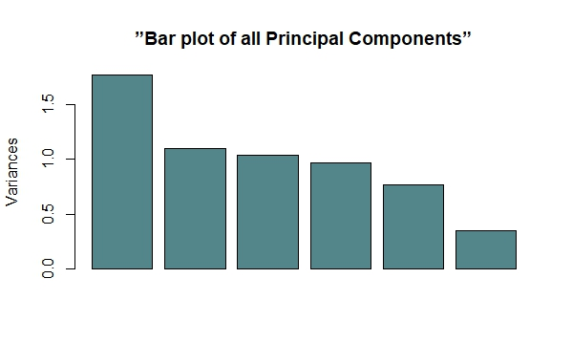

We now need to do a scree plot and reduce the dimensionality of our data set.

Code used:

plot(RoysPRcomp, type = "l", col = "blue",lwd=2)

Output:

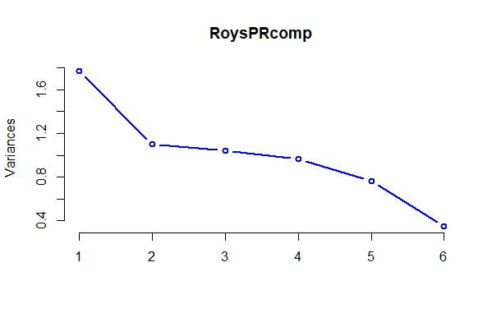

Our scree plot is telling us that we can remove everything after PC2. We now look at a Biplot using the bi plot function as follows:

Code used:

biplot(RoysPRcomp,scale=0)

Output as follows:

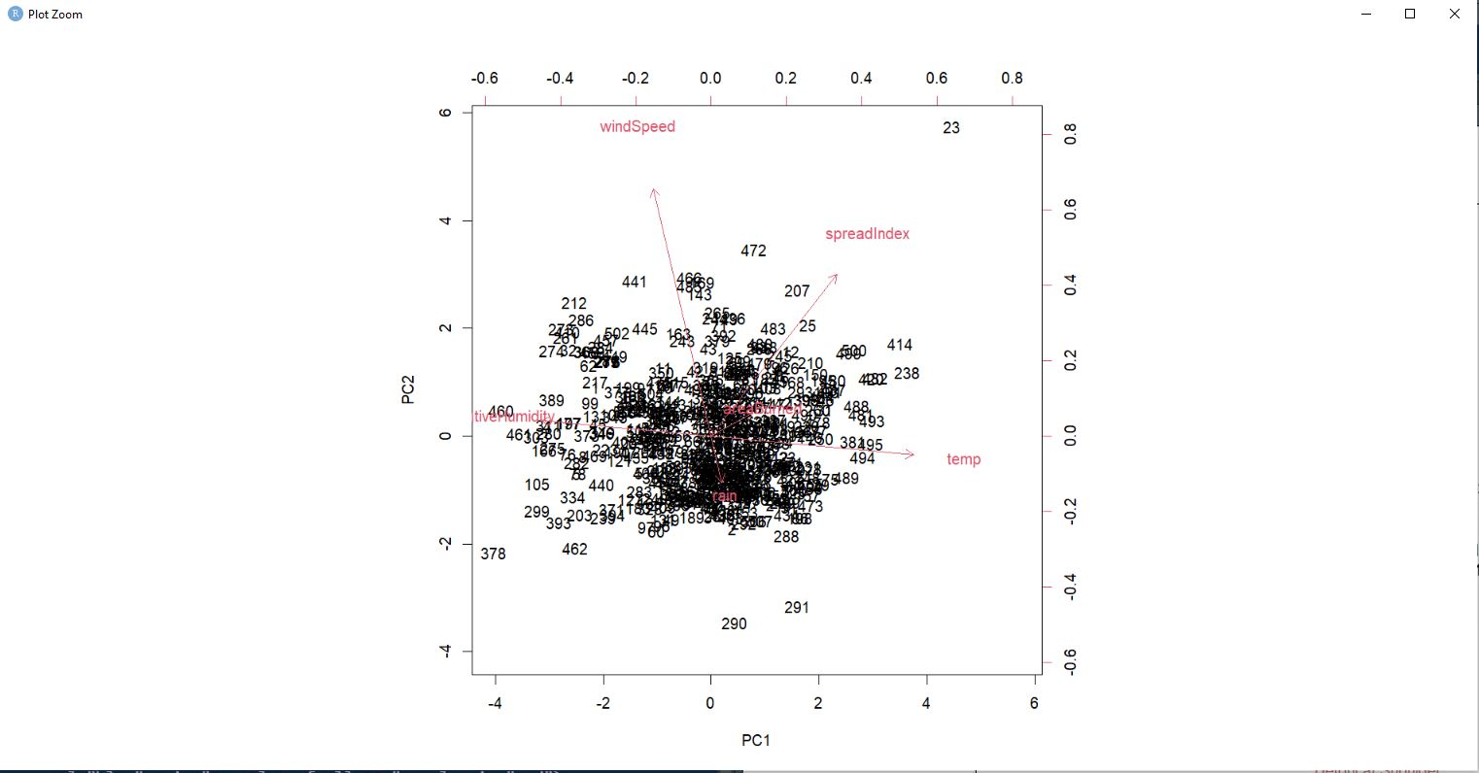

More on this in the discussion.

Let us look at the actual scores of the loadings of our observations. We start by looking at the structure of RoysPRcomp and focus on x, the column of the individual scores of the observations.

We look at x as follows:

RoysPRcomp$x

Output as follows:

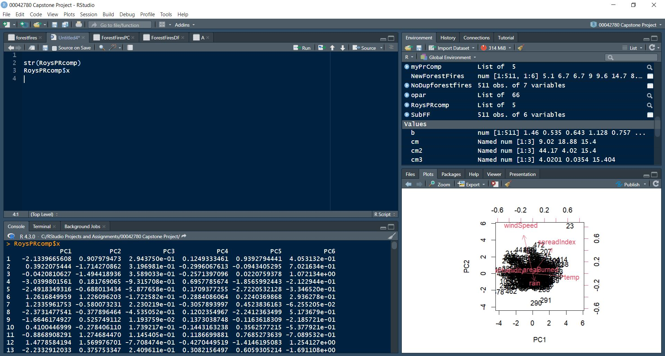

We now need to bind PC1 and PC2, the most important Principal Components onto our data frame with the categorical variable, A.

Code as follows:

ForestFiresCB<-cbind(A,RoysPRcomp$x[ ,1:2])

Having done this, let us look at the head of ForestFiresCB

Output:

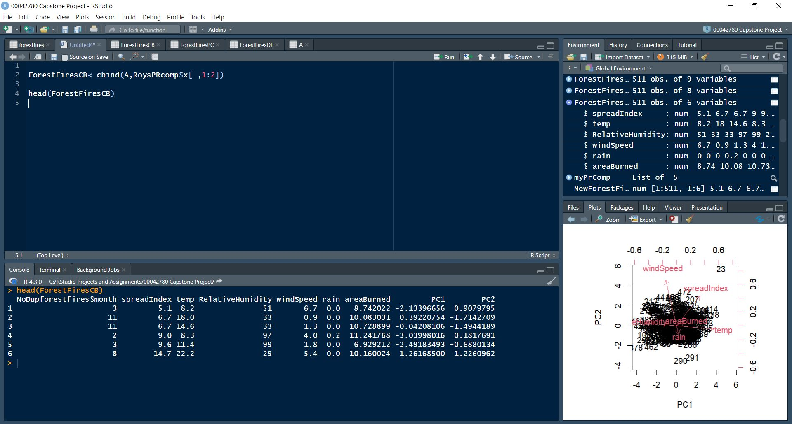

At this point, we have successfully reduced the dimensionality of our dataset.

We now need to look for groupings, as follows:

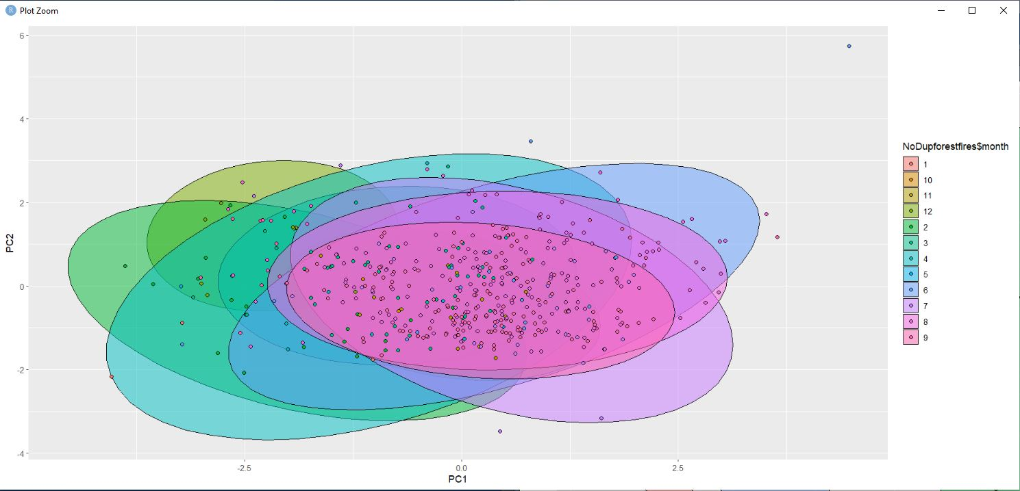

Finally, we need to see a 3D scatterplot of PC1,PC2 and PC3

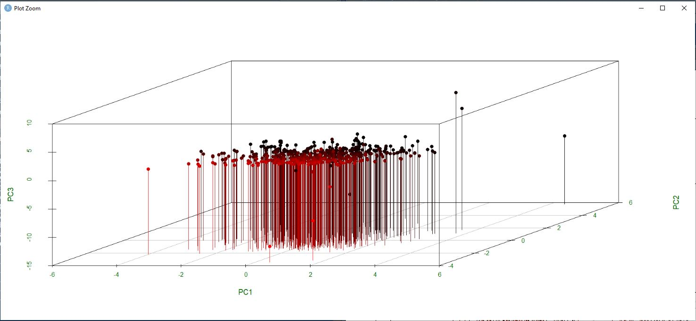

Having fully completed our analysis, let us move on to the discussion section.

**DISCUSSION**

We shall now delve into the actual results obtained throughout the project. To begin with we tested our data set for Normality and Bivariate Independence. We started by doing some Quartile-Quantile plots with differing pairs of variables. The plots don’t seem to follow a normal distribution, as lot of points in each plot deviate greatly from their respective lines. This essentially means that the mean, median and mode are not all located around the center of the distributions. The Shapiro Test for normality confirms the above findings as the corresponding p-values were much smaller than 0.05, deviating greatly from normal distribution, rejecting the null hypothesis of normality.

The Chi plots were very interesting. Looking at the number of points withing the bars versus the number of points outside the bars for each plot, we can say that Area burned, and rainfall are highly dependent on each other. Realistically speaking, more rainfall should equate to less burning, and vice versa, as seen during our dry season.

The Histograms are self-explanatory as they give us an indication of the frequencies of the variables. The dark lines(rugplot) indicate the number of values which fall into the different bars. The Box plots for Relative humidity and Rainfall show many outliers, identified by numerous points above the upper fence. The Barplot of the months variable is also very self-explanatory as it shows that most of the data points belong to the month of August.

Scatterplot matrices show us similar correlations by color, whilst the 3D scatterplots give us visual relationships between triplets of variables.

The graphical tests for Multivariate normality showed Data1 and Data2 being normally distributed. Data3 had too many points deviating from the line. (Details of the makeup of Data1, Data2 and Data3 are above.) Numerous outliers were obtained from the Bivariate boxplots. Further to this, the large angles within the ellipses indicate less correlation between the respective variables. The Mahalaobis distance showed numerous points greater than 9, hence, numerous outliers are in our data set. The Panel plots were used to show correlations between the chosen groups. By observing the plots, we see no correlation between Relative humidity and windspeed. The red bubble plot tells us that higher wind speeds seem to be associated with less rain and less burnt areas. The blue bubble plot seems to indicate that higher levels of humidity are associated with moderate wind speeds.

The Biplot obtained from doing our Principal Component Analysis gives us information on the loadings in our PCs of the individual observations. Wind speed is very high on PC2 but very low on PC1.

Finally, our groupings all overlapped massively (according to months). This could imply that our PCA process may not have been as effective as hoped. This is possibly on account of the correlation between the variables.

**Conclusion**

The entire project, though very tedious, proved very effective in learning more about Data analysis in R. The aims were somewhat achieved. The main technical issue experienced was that scripts would suddenly become unusable. So, any text/code left in a script was un-editable. This resulted in me having to either use the console or create a new script to continue. I am unsure as to whether this is an issue with R or a memory issue relating to the computer I used. I also encountered something of a quirk with R where I was unable to use multiline comments. In Java and HTML, there exists syntax to use multiline commenting so as to maximize the use of the script window. In R however, there doesn’t seem to exist syntax for multiline commentary. The workaround was to highlight multiple lines, then press Ctrl+Shift+C. As simple an issue as this might be, it took a bit of getting used to. Another major issue was the size of the plots for the ellipses for the Bivariate boxplots. For some reason these plots were very small. As a workaround I tried centering the plots and using the zoom function to get a sense of the angles within the ellipses. For this reason, each ellipse is accompanied by a zoomed in copy.

**R Code**

as.numeric(forestfires$spreadIndex)->forestfires$spreadIndex

as.numeric(forestfires$temp)->forestfires$temp

as.numeric(forestfires$RelativeHumidity)->forestfires$RelativeHumidity

as.numeric(forestfires$windSpeed)->forestfires$windSpeed

as.numeric(forestfires$areaBurned)->forestfires$areaBurned

as.character(forestfires$month)->forestfires$month

NoDupforestfires <-unique(forestfires)

length(which(is.na(NoDupforestfires)))

length(which(!complete.cases(NoDupforestfires)))

SubFF<-NoDupforestfires[ ,2:7]

NewForestFires<-apply(SubFF,2,function(x){x<-replace(x,is.na(x),mean(x,na.rm=TRUE))})

A<-cbind(NoDupforestfires$month,ForestFiresDF)

ncol(A)

nrow(A)

head(A)

tail(A)

qqnorm(ForestFiresDF$spreadIndex, col =”blue”,pch=15)

qqline(ForestFiresDF$s,colpreadIndex, lty=1, lwd=2, col=”blue”)

**Normality test for the temperature variable:**

qqnorm(ForestFiresDF$temp,col="red",pch=15)

qqline(ForestFiresDF$temp,lty=1, lwd=2,col="blue")

**Normality test for the Relative Humidity variable:**

qqnorm(ForestFiresDF$RelativeHumidity,col="red",pch=15)

qqline(ForestFiresDF$ RelativeHumidity,lty=1, lwd=2,col="blue")

**Normality test for the wind speed variable:**

qqnorm(ForestFiresDF$windSpeed,col="red",pch=15)

qqline(ForestFiresDF$ windSpeed,lty=1, lwd=2,col="blue")

**Normality test for the Rainfall/Precipitation variable:**

qqnorm(ForestFiresDF$rain,col="red",pch=15)

qqline(ForestFiresDF$rain,lty=1, lwd=2,col="blue")

**Normality test for the area burned variable:**

qqnorm(ForestFiresDF$areaBurned,col="red",pch=15)

qqline(ForestFiresDF$areaBurned,lty=1, lwd=2,col="blue")

qqnorm(ForestFiresDF$spreadIndex,col="red",pch=15,main="Normality test - spread index")

qqline(ForestFiresDF$spreadIndex,lty=1,lwd=2,col="blue")

qqnorm(ForestFiresDF$temp,col="orange",pch=15,main="Normality test - Temperature")

qqline(ForestFiresDF$temp,lty=1,lwd=2,col="blue")

qqnorm(ForestFiresDF$RelativeHumidity,col="green",pch=15,main="Normality test - Relative Humidity")

qqline(ForestFiresDF$RelativeHumidity,lty=1,lwd=2,col="black")

qqnorm(ForestFiresDF$windSpeed,col="purple",pch=15,main="Normality test - Wind Speed")

qqline(ForestFiresDF$windSpeed,lty=1,lwd=2,col="black")

qqnorm(ForestFiresDF$rain,col="lightblue",pch=15,main="Normality test - Rainfall/Precipitation")

qqline(ForestFiresDF$rain,lty=1,lwd=2,col="black")

qqnorm(ForestFiresDF$areaBurned,col="gold",pch=15,main="Normality test - Area burned")

qqline(ForestFiresDF$areaBurned,lty=1,lwd=2,col="black")

**Shapiro tests**

shapiro.test(ForestFiresDF$spreadIndex)

shapiro.test(ForestFiresDF$temp)

shapiro.test(ForestFiresDF$RelativeHumidity)

shapiro.test(ForestFiresDF$windSpeed)

shapiro.test(ForestFiresDF$rain)

shapiro.test(ForestFiresDF$areaBurned)

**Spread Index vs Area burned.**

chiplot(ForestFiresDF$spreadIndex,ForestFiresDF$areaBurned,

main="Chiplot of Spread Index and Area burned",col="green",pch=16)

**Temperature vs Area burned.**

chiplot(ForestFiresDF$temp,ForestFiresDF$areaBurned,

main="Chiplot of temperature and Area burned",col="red",pch=16)

**Relative Humidity vs Area burned.**

chiplot(ForestFiresDF$RelativeHumidity,ForestFiresDF$areaBurned,

main="Chiplot of Relative Humidity and Area burned",col="orange",pch=16)

**Wind speed vs Area burned.**

chiplot(ForestFiresDF$windSpeed,ForestFiresDF$areaBurned,

main="Chiplot of wind speed and Area burned",col="blue",pch=16)

**Rainfall vs Area burned.**

chiplot(ForestFiresDF$rain,ForestFiresDF$areaBurned,

main="Chiplot of rain and Area burned",col="purple",pch=16)

**Chi square tests**

tbl<-table(ForestFiresDF$spreadIndex, ForestFiresDF$areaBurned)

chisq.test(tbl)

**Temperature**

tbl<-table(ForestFiresDF$temp, ForestFiresDF$areaBurned)

chisq.test(tbl)

**Relative Humidity**

tbl<-table(ForestFiresDF$RelativeHumidity, ForestFiresDF$areaBurned)

chisq.test(tbl)

**Wind Speed**

tbl<-table(ForestFiresDF$windSpeed, ForestFiresDF$areaBurned)

chisq.test(tbl)

**Rainfall**

tbl<-table(ForestFiresDF$rain, ForestFiresDF$areaBurned)

chisq.test(tbl)

**Covariance, Correlation and Distance**

cov(ForestFiresDF)

cov(subset(A,NoDupforestfires$month=="3")[ ,c(2:7)])

cov(subset(A,NoDupforestfires$month=="6")[ ,c(2:7)])

cov(subset(A,NoDupforestfires$month=="9")[ ,c(2:7)])

**Distance matrices**

DistForestFires<-dist(scale(ForestFiresDF))

as.dist(round(as.matrix(DistForestFires),2 [1:6, 1:6])

**Histograms, Boxplots and Barplots**



boxplot(A$spreadIndex,xlab="Spread Index",main="Boxplot of Spread Index Variable",col="blue")

boxplot(A$temp,xlab="Temperature",main="Boxplot of the temperature Variable",col="orange")

boxplot(A$RelativeHumidity,xlab="Relative Humidity",main="Boxplot of the Relative humidity Variable",col="green")

boxplot(A$windSpeed,xlab="Wind speed",main="Boxplot of the wind speed Variable",col="purple")

boxplot(A$rain,xlab="Rainfall",main="Boxplot of the Rainfall Variable",col="aquamarine")

boxplot(A$areaBurned,xlab="Area burned",main="Boxplot of the area burned Variable",col="brown")

counts<-table(A$`NoDupforestfires$month`)

barplot(counts,main="Barplot of Months variable",xlab="Frequency",horiz="TRUE",col="rainbow"(12))

**Scatterplots**

## SCATTER PLOTS

attach(A)

plot(spreadIndex,areaBurned,main="Basic scatterplot of Area burned vs Spread Index",xlab="Spread index",ylab="Area burned",pch=19,col="blue")

points(spreadIndex,temp,col="red",pch=16)

legend(locator(1),c("Area Burned","Temperature"),pch=c(19,16),col=c("blue","red"))

opar<-par(no.readonly=TRUE)

par(mfrow=c(1,2))

plot(`NoDupforestfires$month`,areaBurned,col="blue",pch=15,xlab="Months",ylab="Area burned")

plot(spreadIndex,areaBurned,col="red",pch=16,xlab="Spread Index",ylab="Area burned")

opar<-par(no.readonly=TRUE)

par(mfrow=c(1,2))

plot(temp,areaBurned,col="orange",pch=15,xlab="Temperature",ylab="Area burned")

plot(RelativeHumidity,areaBurned,col="green",pch=16,xlab="Relative humidity",ylab="Area burned")

opar<-par(no.readonly=TRUE)

par(mfrow=c(1,2))

plot(windSpeed,areaBurned,col="purple",pch=15,xlab="Wind speed",ylab="Area burned")

plot(rain,areaBurned,col="aquamarine",pch=16,xlab="Rainfall",ylab="Area burned")

par(mfrow=c(1,1)) ## This line of code is used to reset the plots so that

##they are no longer side-by side

Months<-factor(NoDupforestfires$month)

plot(Months,areaBurned,ylab="Area burned",xlab="Months",col="rainbow"(12))

## Scatterplot Matrix for Data1

## Spread Index,temperature, area burned

Data1<-A[c(2,3,7)]

Data1.corr<-abs(cor(Data1))

Colors<-dmat.color(Data1.corr)

Orderings<-order.single(Data1.corr)

cpairs(Data1,Orderings,panel.colors = Colors,gap=5,main="Scatterplot Matrix of Data1 Ordered and Colored by Correlation")

##Scatterplot Matrix for Data2

Data2<-A[c(4,5,7)]

Data2.corr<-abs(cor(Data2))

Colors<-dmat.color(Data2.corr)

Orderings<-order.single(Data2.corr)

cpairs(Data2,Orderings,panel.colors = Colors,gap=5,main="Scatterplot Matrix of Data2 Ordered and Colored by Correlation")

##Scatterplot Matrix for Data3

Data3<-A[c(5,6,7)]

Data3.corr<-abs(cor(Data3))

Colors<-dmat.color(Data3.corr)

Orderings<-order.single(Data3.corr)

cpairs(Data3,Orderings,panel.colors = Colors,gap=5,main="Scatterplot Matrix of Data3 Ordered and Colored by Correlation")

## 3D **Scatterplot Matrices**

attach(Data1)

scatterplot3d(temp,spreadIndex,areaBurned,main="3-D Scatterplot of the variables of Data1",highlight.3d=TRUE,pch=15,type="h")

attach(Data2)

scatterplot3d(RelativeHumidity,windSpeed,areaBurned,main="3-D Scatterplot of the variables of Data2",highlight.3d=TRUE,pch=15,type="h")

attach(Data3)

scatterplot3d(windSpeed,rain,areaBurned,main="3-D Scatterplot of the variables of Data3",highlight.3d=TRUE,pch=15,type="h")

**Multivariate Normality**

## Multivariate Normality

cm<-colMeans((Data1))

cm

Data1covmat<-cov(Data1)

d<-apply(Data1,1,function(Data1)t(Data1-cm)%*%solve(Data1covmat)%*%(Data1-cm))

plot(Qc<-qchisq((1:nrow(Data1)-1/2)/nrow(Data1),df=3),sd<-sort(d),xlab=expression(paste(chi[4]^2,"Quantile")),

ylab="Ordered distances",xlim=range(Qc)*c(1,1.1),col="red",pch=16,main="Multivariate chiplot of Data1")

abline(a=0,b=1,col="blue")

cm2<-colMeans((Data2))

cm2

Data2covmat<-cov(Data2)

e<-apply(Data2,1,function(Data2)t(Data2-cm2)%*%solve(Data2covmat)%*%(Data2-cm2))

plot(Qc<-qchisq((1:nrow(Data2)-1/2)/nrow(Data2),df=3),sd<-sort(e),xlab=expression(paste(chi[4]^2,"Quantile")),

ylab="Ordered distances",xlim=range(Qc)*c(1,1.1),col="orange",pch=16,main="Multivariate chiplot of Data2")

abline(a=0,b=1,col="blue")

cm3<-colMeans((Data3))

cm3

Data3covmat<-cov(Data3)

f<-apply(Data3,1,function(Data3)t(Data3-cm3)%*%solve(Data3covmat)%*%(Data3-cm3))

plot(Qc<-qchisq((1:nrow(Data3)-1/2)/nrow(Data3),df=3),sd<-sort(f),xlab=expression(paste(chi[4]^2,"Quantile")),

ylab="Ordered distances",xlim=range(Qc)*c(1,1.1),col="purple",pch=16,main="Multivariate chiplot of Data3")

abline(a=0,b=1,col="red")

**Outliers**

BiMat1<-as.matrix(ForestFiresDF[ ,c(6,1)])

View(BiMat1)

bvbox(BiMat1,main="Bivariate boxplot of Spread Index and Area burned",xlab="Spread Index", ylab="Area burned",

pch=16,col="red")

BiMat2<-as.matrix(ForestFiresDF[ ,c(6,2)])

View(BiMat2)

bvbox(BiMat2,main="Bivariate boxplot of Temperature and Area burned",xlab="Spread Index", ylab="Area burned",

pch=16,col="green")

BiMat3<-as.matrix(ForestFiresDF[ ,c(6,3)])

View(BiMat3)

bvbox(BiMat3,main="Bivariate boxplot of Spread Index and Area burned",xlab="Spread Index", ylab="Area burned",

pch=16,col="red")

**Mahalanobis Distance**

## Matrix1

MV<-mahalanobis(BiMat1,colMeans(BiMat1),cov(BiMat1))

MV

## We need to find values greater than 9

BiMat1[MV>9, ]

##Matrix2

MV<-mahalanobis(BiMat2,colMeans(BiMat2),cov(BiMat2))

MV

BiMat2[MV>9, ]

**Relationship Plots**

attach(Data1)

plot(xyplot(temp~spreadIndex|cut(areaBurned,3),data=Data1,col="green",pch=15,main="Panel plot

of Area burned vs Spread Index with temperature as conditioning variable"))

attach(Data2)

plot(xyplot(windSpeed~RelativeHumidity|cut(areaBurned,3),data=Data2,col="orange",pch=15,main="Panel plot

of Area burned vs R. Humidity with wind speed as conditioning variable"))

attach(Data3)

plot(xyplot(rain~windSpeed|cut(areaBurned,3),data=Data3,col="lightblue",pch=15,main="Panel plot

of Area burned vs Wind speed with rainfall as conditioning variable"))

**Bubble plots**

r<-sqrt(Data1$spreadIndex/pi)

symbols(temp,areaBurned,circle=r,inches=0.5,fg="white",bg="orange",main="Temp vs area burned with Pt Size 3 prop. to Spread Index")

q<-sqrt(Data2$RelativeHumidity/pi)

symbols(windSpeed,areaBurned,circle=r,inches=0.5,fg="white",bg="blue",main="Wind speed vs area burned with Pt Size 3 prop to R. Humidity")

b<-sqrt(Data3$windSpeed/pi)

symbols(rain,areaBurned,circle=r,inches=0.5,fg="white",bg="red",main="Rain vs area burned with Pt Size 3 prop to Wind speed")

**Principal Component Analysis**

ggpairs(ForestFiresDF)

mahalanobis(ForestFiresDF,colMeans(ForestFiresDF),cov(ForestFiresDF))

hist(mahalanobis(ForestFiresDF,colMeans(ForestFiresDF),cov(ForestFiresDF)),

xlab="Mahalanobis Distance",col="blue",main="Histogram of Mahalanobis Distances")

ForestFiresDF$maha<-mahalanobis(ForestFiresDF,colMeans(ForestFiresDF),cov(ForestFiresDF))

ForestFiresDF$p<-pchisq(ForestFiresDF$maha,df=5,lower.tail = FALSE)

View(ForestFiresDF)

ind<-which.min(ForestFiresDF$p)

if(ForestFiresDF$p[ind]<0.001){print("No distance has a p-value less than 0.001")}

ind<-which.min(ForestFiresDF$p)

if(ForestFiresDF$p[ind]<0.001){print("No distance has a p-value less than 0.001")}

**Multivariate Normality**

qqnorm(mahalanobis(ForestFiresDF, colMeans(ForestFiresDF), cov(ForestFiresDF)), col = "red", cex = 2, pch = 19)

qqline(mahalanobis(ForestFiresDF, colMeans(ForestFiresDF), cov(ForestFiresDF)), col = "black",lwd=2)

**Principal Components**

ForestFiresPC<-ForestFiresDF[ ,1:6]

RoysPRcomp<-prcomp(ForestFiresPC,scale=TRUE)

plot(scale(ForestFiresPC$windSpeed),scale(ForestFiresPC$areaBurned),xlab="Spread Index",ylab="Wind speed",col="blue",pch=16)

plot(RoysPRcomp, type = "l", col = "blue",lwd=2)

biplot(RoysPRcomp,scale=0)

RoysPRcomp$x

ForestFiresCB<-cbind(A,RoysPRcomp$x[ ,1:2])

**References cited.**

DataMentor: "Subplot in R Programming"

Website: https://www.datamentor.io/r-programming/subplot

Statology

Website: https://www.statology.org/

DataMentor: "Subplot in R Programming"

Website: https://www.datamentor.io/r-programming/subplot

Cross Validated (Stats Stack Exchange)

Website: https://stats.stackexchange.com/

West Georgia University: "Scatterplots and Correlation Notes"

PDF: https://www.westga.edu/academics/research/vrc/assets/docs/scatterplots_and_correlation_notes.pdf

"Statistics for Research with a Guide to SPSS" by George Argyrous , (2009 )second edition

"Introductory Statistics" by Prem S. Mann (2004)